Table of Contents
Abstract 3
Preface and Introduction 4
Author’s Assessment of Project 5
1. Background 7
1.1. Background to Scouting 7
1.2. Changes in the Scouting Movement 8
1.3. The Need for the Project 10
1.4. Existing Solutions 10
2. Specification 12
2.1. Objectives 12
2.2. Functionality 12
2.3. Timetable 13
2.4. Resources 14
3. UML Analysis 15
3.1. Use Case Modelling 15
3.2. Static Modelling 18
3.3. Object Structuring 21
3.4. Dynamic Modelling 23
3.5. Consolidated System Collaboration 31
Section 3 Summary 33
4. Choice of Technologies 34
4.1. The Back End: Choice of a Database Engine 34
4.2. The Front end: Interface Technologies 38
4.3. Middleware: Extracting Data and Serving Pages 44
Section 4 Summary 46
5. Database Modelling and Design 47
5.1. Entity-Relationship Modelling 47
5.2. Relation Table Design 51
Section 5 Summary 55
6. Interface Research and Design 56
6.1. Design Inspiration and External Contributions 56
6.2. Principles of Interface Design 58
Section 6 Summary 62
7. Implementation Notes 63
7.1. Programming Conventions 63
7.2. User Access Control Features 65
7.3. Youth Record Management Features 67
7.4. Event Management Features 69
7.5. Reporting Features 70
7.6. Networking Features 72
7.7. Data Maintenance Features 74
7.8. The scouttrack Servlet Package 75
7.9. Site Maps 77
Section 7 Summary 80
8. Software Testing 81
8.1. Testing Programme 81
8.2. Post-development Testing 81
8.3. User Acceptance Testing 83
9. Conclusions & Future Suggestions 84
9.1. Did the Project Meet its Objectives? 84
9.2. How the Project Grew Beyond its Objectives 85
9.3. What Additional Features could be Added? 85
References, Acknowledgements & Glossary 87
General Bibliography 87
Referenced Literature and Sources 88
Acknowledgements 89
Glossary of Scouting Terminology 90
Appendices 92
Appendix A: Original Specification 92
Appendix B: Complete Use Case Analysis 95
Appendix C: Project Diary 104
Appendix D: Example Reports 106
Appendix E: Project Presentation Slides 108
Index 110

Abstract
At the AGM of the Scout Association in 2000, changes in the organisation of the Association were announced by the National Scout Council. To address the administrative requirements of the newly reorganised Association, the need for some computer software was identified. This software would allow the maintenance of youth member records, planning of events and recording of attendances. The software should be easy and intuitive to use, and reduce the current time required for administration.

[Database, Distributed System, Networking, Java, JDBC, JSP, Servlets, Web Server]

Preface and Introduction
This report has been prepared to meet the requirements of course CS310. It details the progression from inception to design to implementation to evaluation of the project between September 2001 and April 2002.

The project differs in part from the original specification submitted in October 2001. A revised specification has been provided in the body of the report, and the original specification is provided in the Appendices.

Components were added to the project as it proceeded. These components were designed after the main design effort in October/November 2001. However, I have chosen to make the report as cohesive as possible and have integrated the design work for later extensions into the main body of the report. I make obvious where these extensions are included by including special notes describing the extension. They appear like this:

Project Extension
…Notes describing the extension…

I have also provided notes at several points in the report explaining why, for example, I chose to develop a static model of the system or why an entity-relationship model is useful to the project. Such notes appear like this:

? | Why did I develop…?  I developed this because…  It assists the project in the following ways…

Any further questions regarding the project can be directed to myself via email on paul.hudspith@bcs.org.uk. The project website can be found at http://www.dcs.warwick.ac.uk/~csuyo.

Paul Hudspith
April 2002

Author’s Assessment of Project
What is the technical contribution of this project?
This project demonstrates the use of the modern, developing technology of JavaServer Pages and Servlets in conjunction with a lightweight, distributable database. By using advanced techniques including JavaScript, layering and dynamic HTML, the project is presented in a browser interface that is just as functional and capable as an equivalent application. The browser interface allows greater customisation and follows the trend toward browser interfaces as a more usable, “friendly” user interface.
How is the project relevant to computer science?
The use of UML as a design technique and the chosen development methodology for the interface mirror computer science’s formal, scientific approach to problem-solving. The design and implementation of the database also exhibits the best practices of relational modelling.
How can others make use of the work in this project?
The servlet package written provides a collection of useful servlets that combine database connection with the ability to run queries, extract results, manipulate those results and rewrite them to the database. With the change of a few variables, several classes could be used in any system with ease. In addition, the interface JSPs and servlets could be placed on top of any middleware/database combination and as such provide an interface to other systems.
Why should this project be considered an achievement?
On a technical note, the project takes numerous components and technologies from a variety of sources and combines them all into an efficient, reliable and platform-portable application that forms an excellent solution to a real-world problem. By computerising a time-consuming task, the project reduces the time Scout Leaders spend on mundane administration, freeing up time for more important tasks such as activites and programme planning.
What are the weaknesses of this project?
Although very capable and reliable, the use of these numerous software tools and technologies makes the implementation somewhat complex. The system runs very quickly, but at the cost of a reasonable overhead on the machine due to the simultaneous support of a database engine, servlet server, web server and JVM. The project is also fairly static and would require major re-working should any more changes in Scouting’s organisational structure be introduced.

Background

Background to Scouting

Scouting’s Aims and Brief History
The Scout Association, like any large organisation, has a mission statement…

“The aim of the Association is to promote the development of young people in achieving their full physical, intellectual, social and spiritual potential, as individuals, as responsible citizens and as members of their local, national and international communities.
The Method of achieving the Aim of the Association is by providing an enjoyable and attractive scheme of progressive training, based on the Scout Promise and Law, and guided by adult leadership.”

The Scouting Movement was founded in 1907 and has grown to a current world youth membership of 28 million. The UK has some 500,000 youth members.

My Involvement with Scouting
I have been involved with Scouting since joining a local Group at age 8. I was a Cub Scout, then a Scout there until age 16 when I became an Instructor. At age 18, I became a Scout Leader and have maintained active links with my District since coming to Warwick.

Organisation of the Movement in the UK
The Scout Association operates with a hierarchy of sub-divisions.

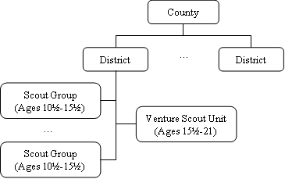
Figure 1-1 – The Current Scouting Hierarchy

- Nationally, the Association is divided into Counties, which roughly follow the geographical lines of County Councils. For example, “Warwickshire” and “Leicestershire” are both Scout Counties.
- Within Counties we have Districts, which roughly follow the geographical lines of District or Town Councils. For example, “Leamington Spa” and “Nuneaton” are both Scout Districts.
- Within Districts we have multiple Scout Groups and a Venture Scout Unit. Groups are broken up internally by age ranges. Examples of Scout Group names are “1st Leamington Spa” or “3rd Nuneaton” (numbers generally indicate the order in which Groups were founded). Venture Scouts are aged 15½-21 and operate independently of any Scout Group.

NOTE: All this Scouting information and more can be found in the 'Glossary of Scouting Terminology’ on page 89.

Changes in the Scouting Movement
The need for my project arose from the national commitment in 2000 to radical changes in the organisation of the Association. These changes were planned following a national programme review.


The Programme Review Implementation
The Programme Review Implementation (PRI) is the series of changes decided on by the National Scout Council, based on information gained in the review mentioned previously.

Essentially, it restructures the hierarchy shown in Figure 1-1 by introducing an additional section between the Scout and Venture Scout sections.

This new section, to be known as the Explorer Scout Unit will take the place of the existing Venture Scout Unit at District-level. It will draw its members from the Scout Groups at age 14 year rather than the current 15½ years.

The Venture Scout Unit will move up the hierarchy and be run at County- rather than District-level. Members will now be drawn from the Explorer Scout Units of the Districts within the County at age 18 years. Finally, the upper age range for Venture Scouts will increase from 21 years to 25 years.

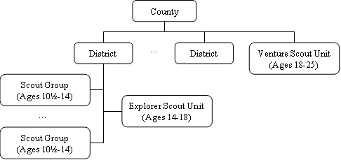
Figure 1-2 - The New Scouting Hierarchy

Timetable for the Changes

When? | What? | Who?
23rd September 2000 | Introduction for the implementation of changes | Members of the National Council of the Scout Association
Autumn 2000 | Regional launches | County/District Commissioners and their teams
June/July 2001 | Preparation for the change in age ranges | County/District leaders with responsibility for new sections
March 2002 | New programme and support material launched | All Members
December 2003 | New programme in place | All Members
Table 1-1 - Timetable for the Programme Review Implementation

As can be seen from Table 1-1, the Association is (at the time of writing) currently well in to carrying out the PRI some 18 months after its initial launch.

The Need for the Project

Traditional Administration
When I was instructing and later leading in my Scout Group, we met for two hours a week on a Wednesday evening. On average, myself and the other leaders would spend at least that time again weekly performing administrative tasks including:

- Keeping youth members’ records up-to-date.
- Reading correspondence from District, County and National sources.
- Planning trips and events.
- Planning the programme for the following weeks.

All members and sections of the Scout Association are governed by the publication Policy, Rules and Organisation (PRO). PRO mandates that all these tasks be carried out to certain standards. Where youth records and event planning are particularly concerned, a very precise path using various forms and booklets produced centrally by the Association must be followed.

Addressing Administrative Needs by Computer
I have been aware for some time that a more automated system for administrating youth members and events would be very useful. The introduction of the Explorer Scout section can only increase the overall administrative load within a County.

The project requirement has given me the chance to implement a solution to the administrative headache at an ideal time in the transition to the new organisational structure.

Existing Solutions

The Scout Association are very active on the IT front. Their website, www.scoutbase.org.uk, active since 1996, receives millions of annual visits. In addition there are numerous pieces of software available shareware or freeware that address various Scouting issues.

The majority of these software tools are aimed at the Boy Scouts of America (BSA) and are not relevant to Scouting in the UK. Although both part of the World Organisation of the Scout Movement, organisational, training and award structures are very different there.

The only software tool available that bears any relation to the problem this project was envisaged to solve is the Venture Scout Training Database. This is a Microsoft Access database application written by Steve Allen, a Venture Scout Leader from the East Sussex Scout County. It focuses around the progress of Venture Scouts through the progressive training scheme and, as such, fulfils only part of the project requirements presented by the Abstract.

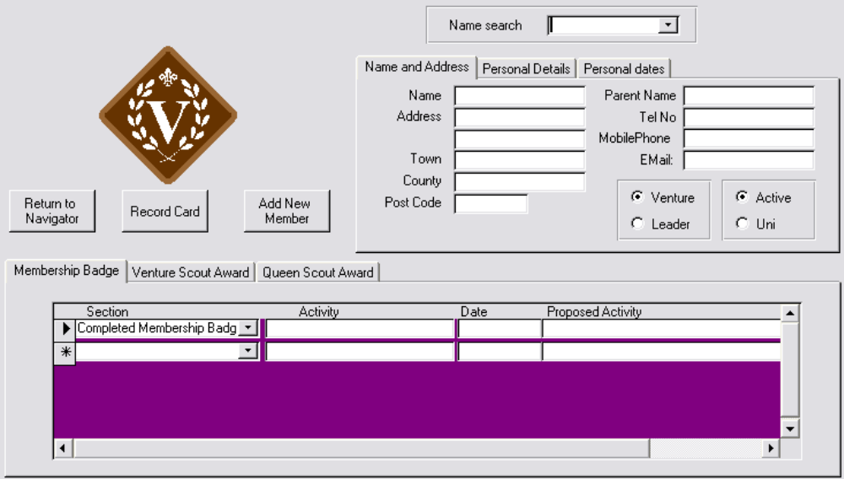
Figure 1-3 - The Venture Scout Training Database

Its recording of Venture Scout details and award progress is excellent and easy to use, but there is no consideration of events in the system, and no functionality to produce reports.
Another problem with this system (as with all the others I looked at) is that they are too old to recognise the changes in the Association brought about by the PRI.

In summary, this project will aim above and beyond the scope of existing tools that are available.

Specification
The specification is a statement of the aims of the project, the functionality required and resources that will be used to develop the software. This is a specification revised in light of issues that arose between submitting the specification in October 2001 and implementing the solution over the coming months. The original specification can be found in Appendix A on page 93.

Chronologically, a lot of the research into implementation technologies was performed before the specification was prepared, but appears in later sections. Decisions on methods and technologies included in the specification are justified in these later sections.

Objectives

- Specify as precisely as possible the desired capabilities of the system
- Produce a detailed, unambiguous design for the system using UML
- Implement the District sub-system for Youth Member information management.
- Add functionality to the District sub-system for handling event management
- Produce a modified District sub-system to function as the County sub-system
- Implement the cross-database communication facility for Youth Member information
- Add ability to synchronise events and reference information between the databases
- Perform rigorous, documented testing on all parts of the system
- Produce user documentation and reference material

Functionality

The desired finished project will consist of three major functional parts:

The District-level Database sub-system
- A browser-based GUI interacting with a MySQL database as its data source via JDBC embedded in Servlets and JavaServer pages.
- Will be an independently functional system running on a Windows PC.
- Will store information including personal details, scouting history, awards and event attendance for youth members in the Explorer Scout section.
- Will provide a tool to manage events (training, camps, visits, etc…) within the District.

The County-level Database sub-system
- Will be used by adult and youth members of the County’s Venture Scout Unit.
- Similar browser-based interface to MySQL, this time hosted centrally on a web server.
- Information will be stored about youth members and events. Here, youth members will be able to connect to the website and view both a summary of information held about them and a calendar of upcoming events.

The Cross-Database sub-system
- To reduce administrative overheads an application which links the two databases, allowing the transfer of information between the sub-systems, will be developed.
- Multiple District databases will be able to connect up to a single County database via the internet.
- Transfer of youth members’ records from the District databases to the County database when they physically transfer Units at age 18 will be possible.
- To be implemented using basic TCP socket changes in the District sub-system to connect to the remote County database.

Timetable

Week | Objective
2 | Hand in draft Specification
3 | Finalise Specification, Begin UML Use Case Model
4 | Complete Use Case Model, Begin Static Model
5 | Complete Static Model, Dynamic Model
6 | Finalise and combine UML design elements
7 | Database design, modelling and creation
8 | Background research into Servlet/JSP implementation
9 | Web interface design and production
10 | Further coding of JSP/Servlets to support interface
Xmas | Complete District subsystem to operable state
11 | Find a host and build a suitable environment for County subsystem.
12-13 | Research into methods of linking the databases
14-16 | Database interface coding
17-18 | Testing and documentation
19 | Preparation for presentation
20 | Presentation, Commence final report
Easter | Finalise report and documentation
21 | Hand in report
Table 2-2 - Project Timetable

Resources
- The District sub-system will primarily be developed on my home PC using Macromedia’s Dreamweaver, text editors and MySQL’s in-built query tools. My laptop computer will be used to run the District sub-system for testing purposes, simulating the remote client.
- The County sub-system will be server-hosted. My home PC is set up with the Windows XP Professional Operating System and runs Apache's HTTPD web server and Tomcat JSP server.. This, combined with my broadband connection to the internet allows it to function as a web server and hence a testing environment.
Backup will be performed on a regular basis both locally using my LS-120 SuperFloppy disk drive and CD-Writer. Offsite, I plan to regularly backup my work via FTP onto servers both at the Department and in my personal webspace at NTL.

UML Analysis

Use Case Modelling

? | What is a ‘Use Case Model’ and why is it useful to the project?  The Use Case model is a collection of scenario descriptions that is used to capture and describe the functional requirements of a system from the user’s point of view.  The model has the purpose of ‘scoping’ the project and giving some structure to future stages of the design. These later stages must be comprehensive enough to include all the cases outlined by the model.

Project Extension
The use cases for the administrator actor are included in the model. These detail the ability of this actor to add, amend and remove user accounts from the system, as well as contact users via email.
The use cases involved with report generation are also included. The three cases are View Member Summary / View Personal Summary, View Calendar and View Attendance Register.

A comprehensive analysis of each individual use case was conducted. Some examples of these analyses are given here, the remainder are located in Appendix B. The Login and ViewCalendar use cases are the examples that apply to all actors*, as any user of the system must first pass through login to perform any tasks and can also view the calendar of forthcoming events. The OpenYouth use case analysis is also given; this is an example of a heavily used use case.

Login Use Case
Summary: System validates username and password.
Preconditions:
- System is idle, displaying an initial welcome message.
Process:
- System prompts for username.
- Leader/Youth enters username.
- System prompts for password.
- Leader/Youth enters password.
- System checks whether the username and password are valid and displays a login confirmation screen if so.
Alternatives:
- If the username or password is not valid, Leader/Youth is informed and the system returns to its initial state, displaying a welcome message.
Postconditions:
- Username and password of Leader/Youth have been validated.

ViewCalendar Use Case

Summary: Leader/YouthMember views a calendar of all upcoming events
Preconditions:
- System is idle, displaying the menu screen.
Process:
- Leader/YouthMember chooses to view event calendar.
- System displays a calendar of forthcoming events
- Leader/YouthMember chooses to end viewing
- System returns to the menu screen.
Alternatives:
- None
Postconditions:
- Leader/YouthMember has viewed a calendar of forthcoming events.

OpenYouth Use Case
Summary: Leader opens a youth member’s records from the database
Preconditions:
- System is idle, displaying the menu screen
- At least one youth member profile exists in the system
Process:
- Leader chooses to amend, delete or transfer a youth member’s records.
- System prompts the Leader to specify which youth member’s information he /she wants to amend
- System calls up stored information for that youth member.
Alternatives:
- No youth member records are specified in the database and hence Leader is unable to open any details; System prompts Leader of this.
Postconditions:
- The youth member’s records have been successfully opened

Consolidated Use Case Model
This shows all the use cases interacting with each other. Their in-depth analyses can be found in Appendix B.
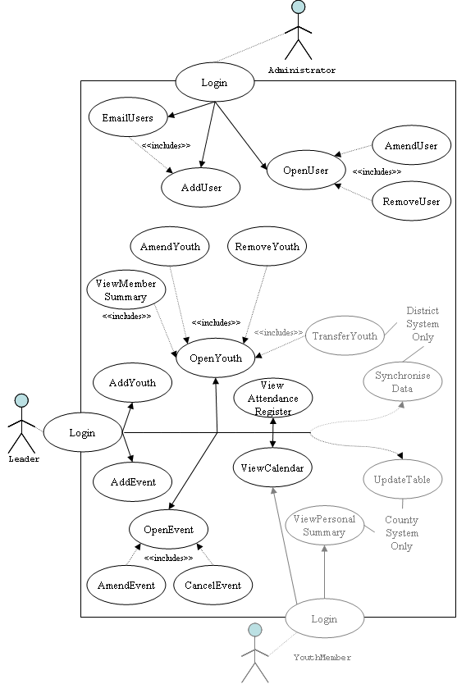
Figure 3-4 - Consolidated Use Case Model

Static Modelling

? | What is a ‘Static Model’ and why is it useful to the project?  The static model of the system shows the classes in the design, the relationships that exist between them and the methods they contain.  The model helps by breaking the system down into smaller chunks. This allows us to more easily bridge the gap between program code and the dynamic models of data flow in the system.

The structural relationships that hold between the pieces of data manipulated within and by the system are described here. This includes the means by which data is split between objects and how we categorise these objects and their inter-relationships.

Perhaps unconventionally, the static model of the system was not prepared before the dynamic model. In my opinion, developing static and dynamic models independently is a bad idea as information on data flow (the dynamic model) can be used to produce a more appropriate class structure (the static model). As a result of this, the two models have been developed together and the static model is placed first simply by convention.

Static Modelling of the System Context
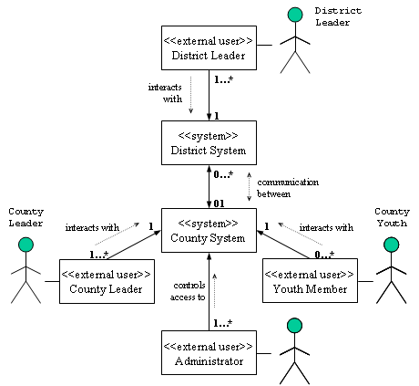
Figure 3-5 - System Context Diagram demonstrating the distributed nature of the system
This context class diagram shows the high-level structure of the system and how different major entities work together in a distributed environment.

The Problem Domain
- Access to the system is controlled through a collection of user accounts
- The system contains and manages database of youth members’ records
- The system contains and manages a database of events
- A member record contains a personal/scouting profile and an attendance profile and exists either at County- or District-level
- An event contains an event profile and a collection of attendances, and exists at both County- and District-level

The conceptual static model of the problem domain shows these classes. These classes correspond to the physical objects in the system.
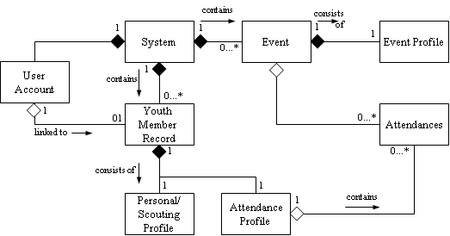

Figure 3-6 - Conceptual Static Model of the Problem Domain (Physical Classes)

Entity Class Details & Attributes
Considerations of the objects participating in the use cases suggest the classes for the system.
- DistrictLeader and CountyLeader schedule Events (detailed by an EventProfile) and record attendances in an AttendanceProfle.
- DistrictLeader and CountyLeader manage a database of YouthMemberRecords (containing a PersonalProfile and an AttendanceProfile).
- YouthMembers can view their PersonalProfile and AttendanceProfile (in the County system)

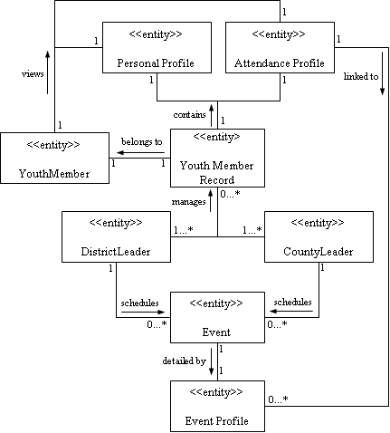
Figure 3-7 - Conceptual Static Model of the Problem Domain (Entity Classes)

The attributes of these entity classes are as follows:

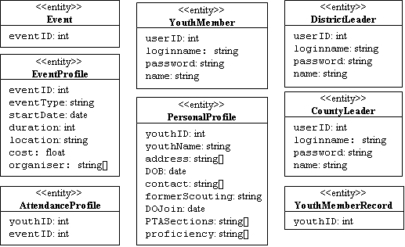
Figure 3-8 - Conceptual Static Model: Entity Class Attributes

Object Structuring
The next step in designing the software was to model and visualise physical objects that exist within the system.

Project Extension
The extension of the project to add an access-control administrator role begins to take shape here with the inclusion of an administrator’s interface alongside the interfaces for other actors.

Client/Server Object Architecture
The major subsystems of the distributed database system as a whole are shown here in a client/server-style architecture. The inter-database communication tool is hidden directly from the end users, who merely interact with the District/County subsystems.

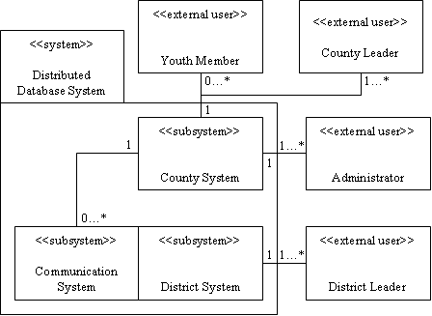
Figure 3-9 - Major client/server subsystems

System Interface Objects
The different means by which the actors each interface with the system as a whole can now be modelled. From each of their viewpoints, the system is an integrated whole, with which they can each interact via their own interfaces.
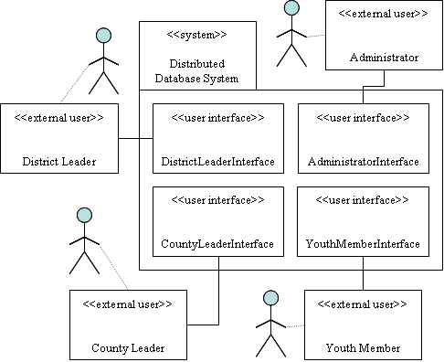
Figure 3-10 - User/system interface objects

Linking Subsystems at the Object level
The subsystems were then able to be linked via objects that are transferred or shared between them, namely YouthMemberRecords and Events. The TransferYouth and SynchroniseData labels in Figure 3-11 represent the use cases that trigger the interaction of the subsystems.

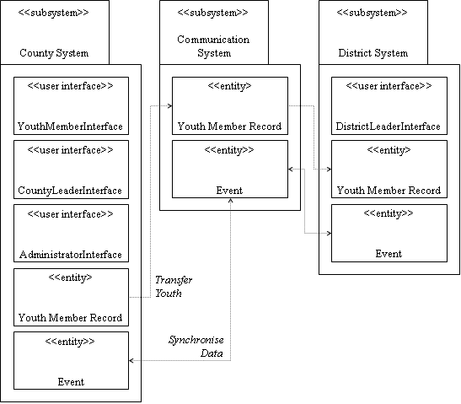
Figure 3-11 - Object-level links between subsystems

Dynamic Modelling

? | What is a ‘Dynamic Model’ and why is it useful to the project?  In the dynamic model we model the flow of data within the system. This is very useful as we can identify potential bottlenecks and, equally, areas of the system that can be reused by different components.  The model also helps to visualise the sequence of events and screens that will appear to the user as they walk through different use cases.

Ideally, a comprehensive model for each of the use cases would be developed. Not dynamically modelling all use cases is not a huge problem, as each actor’s associated use cases share a lot of common features. Two use cases are modelled and demonstrate between them some use of every aspect of the system, the first relatively simple and the second being a more involved use case.

NOTE: Items in courier font are entities within the system (see Figure 3-7, page 20); items in italics are output events or messages from entities.

CountyLeader’s AddEvent use case
In this use case a leader at County Level schedules an event in the system.

Message Sequence

Open the form to input event details to
1.1. CountyLeader actor inputs ‘create event’ selection to CountyInterface
1.2. CountyInterface sends a ChangeScreen(NewEvent) message to CountyControl.
1.3. CountyControl transforms to the Initialising state. The output event associated with this transition is InitialiseNewEvent.
1.4. CountyControl issues an InitialiseNewEvent message to the Event object.
1.5. A new EventProfile is initialised and a SuccessInitialise message is issued to CountyControl.
1.6. CountyControl transitions to the ActiveUser state. The output event associated with this transition is DisplayForm.
1.7. CountyControl issues a DisplayForm message to CountyInterface.
1.8. CountyInterface displays a blank form ready for CountyLeaderr to input the event details.

Save the details
2.1. CountyLeader inputs event details and requests to save the event.
2.2. CountyInterface sends a SaveRequest message to CountyControl.
2.3. CountyControl transforms to the GetScreenData state. The output event associated with this transition is GetDisplayedData.
2.2. CountyControl issues a GetDisplayedData message to CountyInterface.
2.5. CountyInterface packages all of the data for that member and returns it to CountyControl along with a SendDisplayedData message.
2.6. CountyControl transforms to the SaveScreenData state. The output event associated with this transition is StoreEventProfile.
2.7. CountyControl issues a StoreEventProfile message to the Event entity along with the event profile records.
2.8. Event entity stores the profile in its EventProfile and issues a SuccessfulStore message to CountyControl.
2.9. CountyControl issues a SuccessfulSave message to CountyInterface.
2.10. CountyInterface notifies CountyLeader of the successful save of information.
2.11. CountyLeader confirms their understanding, CountyInterface returns to displaying the initial entry options screen.

Entity/Subsystem/Control Collaboration Diagram
Figure 3-12 shows collaboration of the subsystems, entities and control relevant to the County CreateEvent use case. All messages marked relate to the message sequence detailed previously in this section. This diagram allows better visualisation of the nodal, centrally-controlled nature of the system.
All entities and subsystems interact through the state-dependent CountyControl which handles all synchronous and asynchronous activities, including data transfer and message passing.

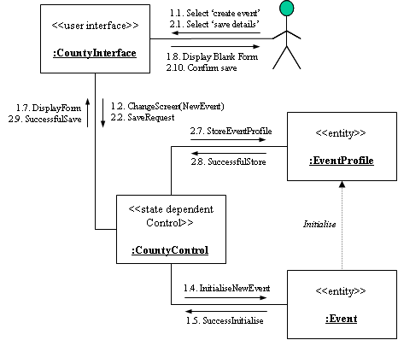
Figure 3-12 - County CreateEvent use case Collaboration Diagram
Sequence Diagram
The sequence diagram Figure 3-13 shows the series of messages that are passed between the various entities, the interface and control as the use case proceeds.

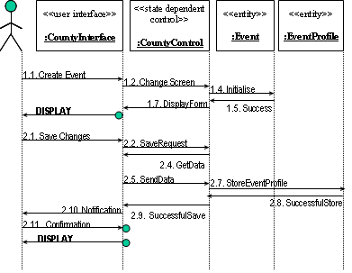
Figure 3-13 - Sequence Diagram for County CreateEvent use case
State Transition Chart
This chart details the changes in state that the CountyControl experiences as the use case progresses.
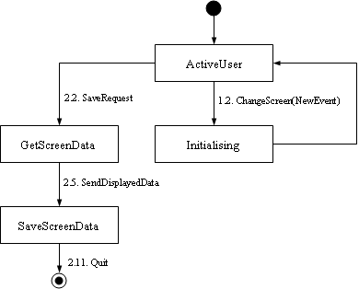
Figure 3-14 - State Transisition Chart for the County CreateEvent use case

DistrictLeader’s AmendYouth Use Case
This district-level use case demonstrates the use of retrieving and saving of information on both members and events, hence is a good exemplification of dynamic data transfer within the system. Of course, the CountyLeader’s AmendYouth use case has a virtually identical makeup to this use case.

Message Sequence
Allow the user to choose which youth member he/she wants to amend
1.1. DistrictLeader actor inputs amend youth selection to DistrictInterface
1.2. DistrictInterface sends a ChangeScreen(Selection) message to DistrictControl.
1.3. DistrictControl transforms to the GetMemberData state. The output event associated with this transition is GetMemberSummary.
1.4. DistrictControl sends a GetMemberSummary message to the set of YouthMemberRecords.
1.5. YouthMemberRecord returns a summary set of records of youth members registered to DistrictControl with a SendMemberSummary message.
1.6. DistrictControl transforms to the SendMemberData state. The output event associated with this transition is SendMemberData.
1.7. DistrictControl orders and formats the relevant records and returns the set to DistrictInterface along with a SendMemberData message.
1.8. DistrictControl transitions to the ActiveUser state.
1.9. DistrictInterface displays the records on screen for user selection.

Open youth member records based on the selection from section 1
2.1. DistrictLeader actor inputs choice of youth member to DistrictInterface.
2.2. DistrictInterface sends a ChangeScreen(DetailDisplay) request to DistrictControl
2.3. DistrictControl transforms to the GetMemberData state. The output events associated with this transition are GetProfile, GetAttendance.
2.4. DistrictControl sends a GetProfile message to the relevant PersonalProfile entity.
2.5. PersonalProfile entity returns the personal records for that youth member to DistrictControl along with a SendProfile message.
2.6. DistrictControl sends a GetAttendance message to the relevant AttendanceProfile entity.
2.7. AttendanceProfile entity returns the attendance records for that youth member to DistrictControl along with a SendAttendance message.
2.8. DistrictControl transforms to the GetEventData state. The output event associated with this transition is GetEventSummary.
2.9. DistrictControl issues an GetEventSummary message to the set of EventProfile entities.
2.10. EventProfile packages and return the content of the entities to DistrictControl together with a SendEventSummary message.
2.11. DistrictControl transforms to the SendPackage state. The output event associated with this transition is SendPackage.
2.12. DistrictControl packages the profiles together and returns the data to DistrictInterface together with a SendPackage message.
2.13. DistrictControl transitions to the ActiveUser state.
2.14. DistrictInterface displays the youth member’s details on screen, ready for DistrictLeader to modify.

Save the amended records
3.1. DistrictLeader modifies details and inputs the request to save changes.
3.2. DistrictInterface sends a SaveRequest message to DistrictControl.
3.3. DistrictControl transforms to the GetScreenData state. The output event associated with this transition is GetDisplayedData.
3.4. DistrictControl issues a GetDisplayedData message to DistrictInterface.
3.5. DistrictInterface packages all of the data for that member and returns it to DistrictControl along with a SendDisplayedData message.
3.6. DistrictControl transforms to the SaveScreenData state. The output event associated with this transition is SendMemberProfiles.
3.7. DistrictControl separates the incoming data into sets for the profiles.
3.8. DistrictControl issues a StoreProfile message to the PersonalProfile entity along with the personal profile records.
3.9. PersonalProfile entity stores the personal profile and issues a SuccessfulStore message to DistrictControl.
3.10. DistrictControl issues a StoreAttendance message to the AttendanceProfile entity along with the attendance profile records.
3.11. AttendanceProfile entity stores the attendance profile and issues a SuccessfulStore message to DistrictControl.
3.12. DistrictControl issues a SuccessfulSave message to DistrictInterface.
3.13. DistrictInterface notifies DistrictLeader of the successful save.
3.14. DistrictLeader confirms their understanding, DistrictInterface returns to displaying the initial entry options screen.
Entity/Subsystem/Control Collaboration Diagram
As in the previous use case, all entities and subsystems interact through the state-dependent control, DistrictControl which again handles all data transfer and message passing.

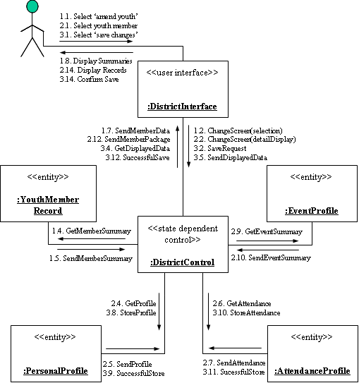
Figure 3-15 – District AmendYouth use case Collaboration Diagram

Sequence Diagram

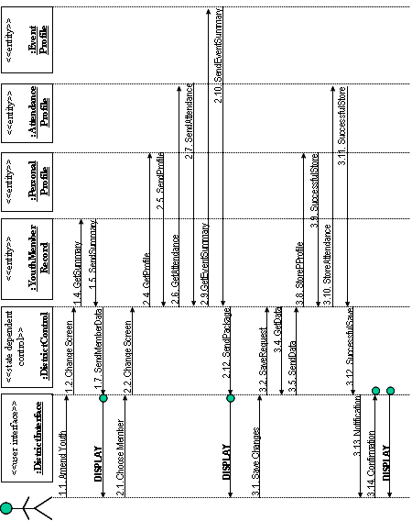
Figure 3-16 - Sequence Diagram for the District AmendYouth use case

State Transition Chart

The state transition chart for the state-dependent DistrictControl object is shown in Figure 3-17. As this use case involves more functionality than the County CreateEvent use case detailed earlier, there are a greater number of control states and more transitions between them.

From these two use cases we can already identify the GetScreenData state as being duplicated between the two use cases. When implementing the system, state duplication is an important consideration for maximising reuse of data structures and methods within the program code.

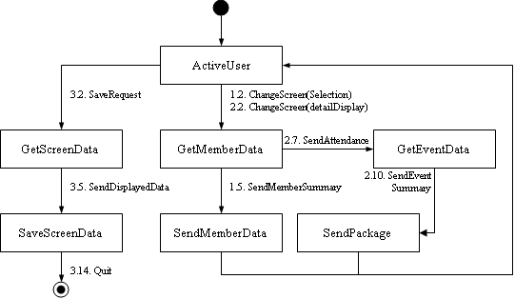
Figure 3-17 - State Transisition Chart for the District AmendYouth use case

Consolidated System Collaboration
Figure 3-18 demonstrates the entities of the distributed system as a whole co-operating, with descriptions of all the messages they exchange under normal running of the system.

Project Extension
The role of the administrator in administrating leaders’ and youth members’ access to the system is incorporated in this overview of general collaboration.

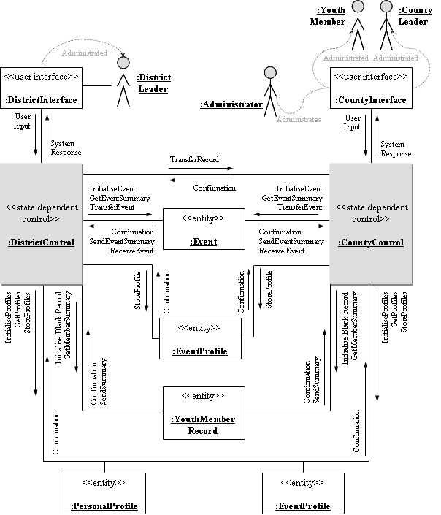

Figure 3-18 - Consolidated distributed system collaboration diagram

Section 3 Summary
This section detailed the development of a comprehensive model of the system using the Unified Modelling Language (UML). This consisted of:

- A Use Case Model (section 3.1, page 15) to capture and describe the functional requirements of the system from the user’s point of view.
- A Static Model (section 3.2, page 18) showing the classes in the design, the relationships that exist between them and the methods they contain.
- Details of Object Structuring (section 3.3, page 21) to model and visualise physical objects that exist within the system
- A Dynamic Model (section 3.4, page 23) detailing data flow within the system, exemplified with an in-depth analysis of data flow for two use cases
- A Consolidated Collaboration Model (section 3.5, page 31) which gives an overview of how all the various entities, interfaces, etc… interact as a whole.

Choice of Technologies
Although the technologies used to satisfy the requirements of different areas were chosen for different reasons, certain core features are required of/desired from all of them:

- Platform-independence - Desirable as the County system will be run from a web server, whereas the District system runs on a Windows PC. As the majority of web servers run a flavour of UNIX, ideally we require a solution that runs under UNIX as well as Windows.

- Availability of software – Freeware/Shareware is desirable. For example, using Sybase or Oracle to provide a database would be ideal, but the cost of such software makes using it in the project impossible.

There are three categories of software that need to be chosen: database, middleware and interface

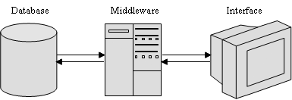
Figure 4-19 - Interaction of Database, Middleware and Interface

At a basic level:

- The database will store all the information on youth members, events, awards, etc…
- The interface will present the information from the database, allow modification of this information and insertion of new information.
- The middleware is responsible for extracting the relevant raw data from the database and organising it into a form readable by the interface.

The Back End: Choice of a Database Engine
Two open-source database engines were considered, PostGreSQL and MySQL.

PostGreSQL and MySQL: Some Background
PostGreSQL (all quotes from http://www.postgresql.org)
- ‘The most advanced open-source database available anywhere’.
- ‘…provides SQL92/SQL99 language support’.
- ‘offers substantial additional power by incorporating…inheritance, data types, functions’.
- ‘Permission to use, copy, modify, and distribute this software for any purpose, without fee, and without a written agreement’.
- ‘in the category of databases referred to as object-relational…although PostGreSQL has some object-oriented features, it is firmly in the relational database world’.
MySQL (all quotes from http://www.mysql.com)
- ‘The world's most widely used open source database’.
- ‘Minimalistic approach in producing functionally rich features resulting in a fast, compact and stable DBMS’
- ‘A client/server system that consists of a multi-threaded SQL server that supports different backends, several different client programs and libraries, administrative tools, and a wide range of programming interfaces’.
- ‘Anybody can download the MySQL software from the Internet and use it without paying anything…MySQL software uses the GPL (GNU General Public License)’.

Advantages/Disadvantages of the Databases
There is a significant amount of material available that discusses the relative merits of these two databases. This material will now be summarised, and both good and bad points extracted from it.

a) SQL Support
One of the larger areas in which PostgreSQL and MySQL differ is in the SQL commands you can use in each. As SQL is a standard data query language, I expected to be able to apply it equally to each of these databases. Unfortunately, adherence to a standard is a place where SQL databases seem to need improvement.
These two agree on the fundamentals, such as what a basic SELECT, INSERT, UPDATE, or DELETE statement looks like. However, once you step beyond the basics, implementations start to diverge, differing on syntax as well as on which features are actually supported.
An important example is the support of subqueries (or ‘nested queries’) which allow dynamic data sets drawn from the database to interact in more complex ways than atomic SELECT queries. Essentially, PostGreSQL supports these subqueries, whereas MySQL does not. MySQL does provide a means of executing pseudo-subqueries by using temporary tables, but this is both less elegant and less efficient.

b) Speed

One offshoot of MySQL’s limited feature set is that it is very fast at transaction processing (Jepson, 2001) when compared to PostGreSQL. Benchmarks for the two can be found at http://www.mysql.com/information/benchmarks.html (although these benchmark tests were performed by MySQL developers, PostGreSQL does not seem to have made public the details of its benchmark tests). These benchmarks show MySQL to outperform PostGreSQL for the majority of transaction types.

c) The ACID Test

A good way to differentiate databases and test overall quality is to perform an ACID test. ACID is an acronym that describes four properties of a robust database system: atomicity, consistency, isolation and durability as applied to a database transaction (some unit of work within the database).

- Atomicity: For example, a transaction that contains UPDATE, INSERT and DELETE statements is treated as a single unit.
- Consistency: There are only two possible outcomes: either all the statements in an transaction change the database or none of them do.
- Isolation: Keeps transactions separated from each other until they're finished
- Durability: A guarantee that the database will track pending changes in such a way that the server can recover from an abnormal termination

PostgreSQL is ACID-compliant. At a basic level, the standard table handler for MySQL is not ACID-compliant (it doesn't support consistency, isolation, or durability). However, the default table handler does support atomicity using a system of ‘table locks’, and there are other table handlers available that provide further degrees of ACID-compliance.

d) Stability
Tim Perdue, a writer for PHPbuilder.com, investigated ‘if the performance differences between the two were as stark as the MySQL website suggests’ (Perdue, 2000).

 | PostGreSQL | MySQL
+ | Results suggested that PostgreSQL ‘will run smoothly for extended periods of time without trouble’. In addition, when PostgreSQL gets heavily loaded, it just slows down and doesn't quit. | Whereas MySQL loses out to PostGreSQL in robustness, it makes up for it by (apparently) never corrupting data files. Perdue tells us that “I haven't ever seen a single case of database or index corruption in a year” (Perdue, 2000).
- | Perdue says that ‘the problem with Postgres is that when you do have a problem with it, it's usually really bad’ (Perdue, 2000). Problems mentioned include corrupted indexes and multiple same numbers inserted into a primary key. | The investigation revealed that ‘MySQL gives up the ghost randomly and for no obvious reason after running for semi-long periods of time (say 30-60 days)’.
Table 4-3 - Stability considerations with MySQL and PostGreSQL

e) Literature Support

Whilst neither database was found lacking when it came to documentation provided by its authors, bookshop literature was a different story. The university bookshop, for example, contained multiple books on MySQL, including some dedicated to using MySQL with particular interface technologies and methods (including PHP, Perl, ASP and JSP). There were no books on PostGreSQL. A search on Amazon.co.uk yielded seven results for PostGreSQL but 22 for MySQL.

It seemed that more relevant literature exists on integrating MySQL with a variety of servers, platforms and interface technologies than did concerning PostGreSQL.

f) Miscellaneous Points

Brian Jepson, a writer for the reputable O'Reilly and Associates (whose books I have used throughout the course of the project), tells us that MySQL seems to be focused on the needs of Web developers, and PostgreSQL seems oriented to a wider range of application developers (Jepson, 2001). He recommends PostGreSQL when you need complicated sites with transactions or PL/SQL-like∗ scripting (Jepson, 2001).

MySQL has the edge over PostGreSQL when it comes to the software distributed with it and available for it. MySQL’s administration application is easy to use and more capable than PostGreSQL’s alternative. In addition, there are literally dozens of different Query tools and assorted freeware applications for use with MySQL available to download from the internet.

The Decision: PostGreSQL or MySQL?

 | PostGreSQL | MySQL
+ | - Most stable of the two  - More capable under intense usage  - ACID compliant | - Availability of varied, relevant literature.  - Speed  - Better suited to web applications  - Better reputation for maintaining uncorrupted data
- | - Documented problems with index corruption and key violation | - Lack of support for advanced SQL constructs  - Liability to cease functioning if left alone for any length of time
Table 4-4 - Summary of Advantages/Disadvantages of PostGreSQL & MySQL

I took the decision to use MySQL rather than PostGreSQL to provide the database back-end for the project. This was because:

- PostGreSQL’s edge in stability and durability are not especially relevant to my project, as the system was designed with the intention to be under intense usage but was designed with the intention to be monitored regularly.
- Any opportunity to shallow the learning curve for the project was welcomed, so the availability of a wide range of literature that did not tie me to any particular interface or middleware technologies was welcomed.
- Complex SQL constructs will not be required, and the lack of support for subqueries can be worked around a number of ways.

The Front end: Interface Technologies

The most fundamental choice in designing and implementing the interface was whether to base it in a browser or to build an application. I decided to implement a browser-based interface to both District and County variants of the system. There were several reasons for this choice:

- As the County system variant is designed to be centrally hosted on a server, it made good sense to choose a browser-based interface. This is because no specialist software is required to be installed on the users’ machines (beyond a web browser, a very common application). As users will come and go (ie. youth members who join and leave the Venture Scout Unit), this avoids the need for distribution of software to new users.

- The District system is designed to run on a standalone machine. As such, the use of a local Java application (or similar) would be just as acceptable as a browser interface. However, using a browser interface for the District system as well the County system brings a range of benefits, including:
- Reuse of code and graphics (giving shorter development time)
- Portability of user knowledge between the two system variants
- More simple documentation and testing process

- Another major factor was the computer literacy of the end users. Canvassing of Leaders brought to my attention that most of them were experienced with using a home computer to access the internet. A browser-based interface is hence more familiar to my end users, and provides a less threatening means of accessing the system than an application interface.

- Using a browser allowed for a more customisable and configurable interface that could be easily developed and altered using many excellent commercial tools.

Having decided on a browser-based interface, the next major decision was to choose a technology to provide the dynamic content within the interface. Numerous option were considered to satisfy this requirement, including:
- Active Server Pages (ASP)
- Common Gateway Interface (CGI) scripts written in Perl
- Java Applets
- PHP HyperText Preprocessor language (PHP)
- JavaServer Pages/Servlets (JSP).
The different technologies were reviewed according to three criteria: platform-independence, speed and other influential concerns. They were marked on a traffic-light scheme: green for excellent, amber for passable and red for deficient.

Active Server Pages
Having had some previous experience with Active Server Pages, I was initially keen to use them in building my dynamic interface. On closer examination, however, there were deficiencies in the technology which made it unsuitable:

 | Cross-Platform Compatibility  ASP is designed to run either with Microsoft Internet Information Server (IIS) or Personal Web Server (PWS) under Windows which are free, or under UNIX with commercial packages such as Chilli!ASP which are not. In my experience a UNIX server is less likely to support ASP than other technologies such as Perl or PHP.
 | Speed  Although ASP’s session management features are superior to most of its rivals, it suffers in speed due to its COM-based architecture. As John Lim tells us:  ‘When an ASP programmer uses VBScript, he is running a COM object. When he writes to the client, he's calling the Response COM object's Write method. When he accesses a database, he uses another COM object to do so. When he accesses the file system, another COM object is called. All this overhead adds up and slows things down’ (Lim, 2000)
Other Concerns
Given its Microsoft origins, there is a lot of information around on building systems with ASP talking to an Access, SQLServer or FoxPro database (all Microsoft products). There is a minimal amount of documentation available on using MySQL with ASP.
Summary
ASP is a well-established technology, but its particular problems meant it was not really suitable for use in the project.
Table 4-5 - Advantages/Disadvantages of ASP as an interface technology

CGI Scripts written in Perl
Perl is an established, versatile and fully-featured language that has been around for more than 15 years. Used extensively on the web, no analysis would be complete without considering it:

 | Cross-Platform Compatibility  Perl is platform-independent, with few (or no) changes required to port it between different operating systems

Speed
Although faster than ASP, Perl still loses out to PHP and JSP. Newer languages have built on Perl; PHP’s string-manipulation features, for example, show signs of its Perl ancestry. Other features have improved to make the newer languages faster (see below).
Other Concerns
John Lim tells us that Perl’s programming style is unique, and quite unlike other languages. Also, accessing POST/GET variables (which are means of passing information between pages in a website) requires detailed knowledge of HTTP headers or one of many Perl CGI libraries (Lim, 2001).
It is good practice to separate code from data. This allows the programmer to make changes to either without affecting the other. In Perl, print statements are used to generate all HTML, which is not best suited to this project where the majority of the interface will be static.
Summary
Perl is a fully-featured language in widespread use, but loses out when compared to newer alternatives in terms of speed and ease of use.
Table 4-6 - Advantages/Disadvantages of CGI/Perl as an interface technology

Java Applets
The browser-based embodiment of the Java language, applets are small, self-contained programs in their own right.

Cross-Platform Compatibility
Java’s “Write once, read anywhere” philosophy means it will run on any platform with a the JVM for their operating system installed. As this does actually depend on the client having the JVM installed (rather than just requiring the server to have some software installed), applets lose out to server-side scripting.
Speed
Applets are generally larger than the equivalent server-side script, and so take longer to download. Once downloaded, they have to be run on the client machine, which further slows down the end result.
Other Concerns
Java offers better functionality than scripting languages, and running applets in Java’s ‘sandbox’ provides increased security. Strong database support with JDBC is provided and literature is abundant. Finally, I already have a good knowledge of Java from the degree course.
Summary
Although very secure and well-supported, Java applets are considerably slower than the alternatives.
Table 4-7 - Advantages/Disadvantages of Java applets as an interface technology

PHP Hypertext Preprocessor Langage
PHP is an open-source embedded scripting language written specifically for dynamic web page creation

Cross-Platform Compatibility
PHP is completely platform-independent, again with little or no difference between its implementations on different operating systems, providing a PHP server is provided.
Speed
PHP is very fast. It has low overheads thanks to superior memory management than its rivals. For example, in ASP's model, if an ASP file header.asp is included into 20 web pages, then 20 compiled copies of that header.asp are maintained in memory. This is unlike PHP, which only loads include files that are required.
Other Concerns
PHP is reputed to be an easy language to learn and there is a lot of literature available about using it with MySQL.
Summary
PHP is a fast, easy-to-learn and well-supported scripting language specifically designed to generate dynamic web pages.
Table 4-8 - Advantages/Disadvantages of PHP as an interface technology

JavaServer Pages (JSP) and Servlets
A relatively new technology, JSP is Java’s server-side scripting language which incorporates object-orientation into the scripting world. JavaServer Pages are a combination of HTML and ‘snippets’ of Java code which are compiled into Java Servlets (pure Java) when the page is requested by the browser. Where more complex functionality is required, Java Servlets can be written directly in pure Java.

Cross-Platform Compatibility
Being a server-side scripting language, the client operating system is irrelevant. Also, being Java, JSP will run on any operating system provided a JSP server is installed.
Speed
Benchmarks at Caucho show JSP to be faster than Perl and PHP, and claim “Java's outdated reputation for performance problems is no longer deserved” (Ferguson, 2001).
Other Concerns
JSP goes a step further than applets in tying the benefits of object-orientation with those of conventional server-side scripting. There are many books concerning all aspects of JSP including several specifically about integrating it with MySQL.
Summary
JSP/Servlets offer a fast solution and incorporate the benefits of the Java language with the ease of use of other server-side scripting languages.
Table 4-9 - Advantages/Disadvantages of JSP as an interface technology

The Choice: PHP or JSP?
From the analysis I summarised that PHP and JSP were the leading contenders to provide dynamic content to my interface. With very little to choose between the two, I decided that JavaServer Pages were the best choice. This is because:

- I have a strong Java background
- I thought that object-orientation would lend itself well to the project. The transition from the UML static model to a realisation should be easier with JSP. For example, we can create actual Event or YouthMember objects in the software, using constructors to initialise or populate them from the database and manipulate them using their in-built methods. .

Middleware: Extracting Data and Serving Pages
Two important types of software were needed for the project’s middleware components: a server to serve the JSP pages and some drivers to connect the pages to the database.

Linking the Database and Servlets
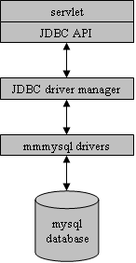
As both the back- and front-end providers had been chosen by this point, the choice of database drivers to link the Java code to MySQL was limited. The only real choice was Mark Matthews’ MM.Mysql driver package. This is available free under the GNU LGPL from http://mmmysql.sourceforge.net.

These drivers were recommended in the majority of literature I came across on the subject, including the two core books I used for this area: JSP, Servlets and MySQL (Harms, 2001) and Core Servlets and JavaServer Pages (Hall, 2001).

Essentially, the driver package contains type IV pure Java drivers. They provide a direct connection between JDBC’s driver manager and the MySQL database. As Harms tells us, type IV drivers are ‘well suited to servlets that connect to a database server on the same hardware or local network’ (Harms, 2001). As such, they were ideal for the project.
Figure 4-20 - The role of JDBC drivers (from Harms, 2001 p.216)

Serving Content
I looked at three options to act as servers for the interface pages:

- Caucho’s Resin (see http://www.caucho.com/)
- Mort Bay’s Jetty (see http://jetty.mortbay.org/)
- Apache’s Jakarta-Tomcat (see http://jakarta.apache.org/)

Although an exhaustive analysis of the three would have been preferable, my investigations revealed that there was very little to choose between them:

- All are platform-independent
- All are well-documented and easy to install/configure
- All are efficient and quick to respond to browser requests

I chose to use Jakarta-Tomcat as my JSP server for a reason outside these mainstream factors. Whilst researching the servers, I came across numerous newsgroup postings that suggested using separate servers to serve static and dynamic content was a good idea. The Jakarta-Tomcat website itself tells us that ‘while it is entirely possible to have Tomcat serve both your static and dynamic document provision needs, there are several reasons why you might not want to do this’ (Jakarta-Tomcat, 2001). With reference to Apache HTTPD, Apache’s mainstream web server, these reasons included:
- Tomcat is not as fast as Apache when it comes to static pages.
- Tomcat is not as configurable as Apache.
- Tomcat is not as robust as Apache.
For all these reasons, the Apache Software Foundation recommends that sites use an ‘industrial-strength web server’ (such as Apache) for serving static content, and use Tomcat as a Servlet/JSP add-on (Jakarta-Tomcat, 2001).

Given Apache’s recommendations and the excellent documentation they had produced on integrating Jakarta-Tomcat and the HTTPD server, I chose to use both of these products to serve pages in the system.

Why Apache HTTPD?

In the world of web server software, two main contenders (and their variants) account for over 90% of global usage according to Netcraft (Netcraft, 2001):

- Microsoft’s Internet Information Server or Personal Web Server (IIS/PWS)
- Apache’s HTTPD Server

Apache has roughly twice the market share of the Microsoft offerings (Netcraft, 2001) and has been ‘the most popular web server on the Internet since April of 1996’ (Apache, 2002). This can be attributed partially to UNIX’s dominance in the server market (IIS/PWS do not run under UNIX, only Windows).

The District system is designed for use under Windows on a standalone home PC, making it a good candidate for using PWS. PWS is intended for use with Windows 95/98/ME, which are likely to be found on a home PC (rather than the NT/2000/XP branch which use IIS). Also, documentation detailing how to run Tomcat alongside IIS/PWS is provided by the Apache Software Foundation.

However, I decided it better to use a common server for both District and County systems. As the County system will be server-based it made sense to use Apache to serve its static HTML content, and so Apache was chosen for use on both variants of the system.

Section 4 Summary
This section detailed the research into and choice of three software tools:
- JavaServer Pages/Servlets to provide the dynamic content in the interface.
- Apache HTTPD/Jakarta-Tomcat to serve the static/dynamic content respectively, and the MMMysql drivers to provide database connectivity.
- MySQL as a database from which to draw data for the dynamic content.
These tools were chosen generally because of their platform-independence, robustness, speed and quality of documentation. The pieces all fit together as shown in .

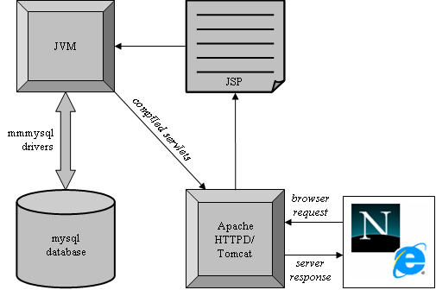

Figure 4-21 - Interaction of the database, middleware and interface

The cycle of actions in the system (when serving dynamic content) is as follows:

- The browser requests a specific page after a user action
- Tomcat requests the relevant servlet from the Java Virtual Machine (JVM). If the JSP page has not yet been compiled into a servlet, the JVM compiles it.
- The JVM populates the servlet with any relevant data from the MySQL database via the mmmysql drivers.
- The populated, compiled servlet is returned to Tomcat.
- Tomcat serves the resultant page to the browser

Database Modelling and Design

Entity-Relationship Modelling

? | Why did I produce an Entity-Relationship Model?  An Entity-Relationship model is a good way of making the transition from a real-life problem scenario to a database representation of the solution. The information trying to be represented can be written down and, from the resulting model, a database can be designed.

Core Entity Description
There are two central entities in my database model, these being the Youth Member and the Event. Most of the entity attributes are self explanatory, but some require additional detail:

Youth Member Entity
Attribute | Explanation
Dietary Notes | Used when organising catering for an event. Nut allergies, vegetarian preferences, etc… are examples of data that could be stored here.
Medical Notes | Similar to dietary information, it is important to know of certain medical problems which could arise in the course of normal meetings or events. This is especially needed when engaging in adventurous and outdoor activities.
Table 5-10 - Additional explanation of Youth Member entity attributes
Event Entity
Attribute | Explanation
Cost Type | Events can be priced per person or per day.
Confirmed? | Events can be organised provisionally and then confirmed at a later date. Again, this is a duplication of the real process. An event will be proposed and, after conferring with other leaders/youth members, checking availability, etc… will be confirmed.
Organiser’s Name/Phone/ Email | The organiser of the event may or may not be involved with Scouting and so attributes to record their contact details are provided whilst not being linked to any other entities.
Table 5-11 - Additional explanation of Event entity attributes

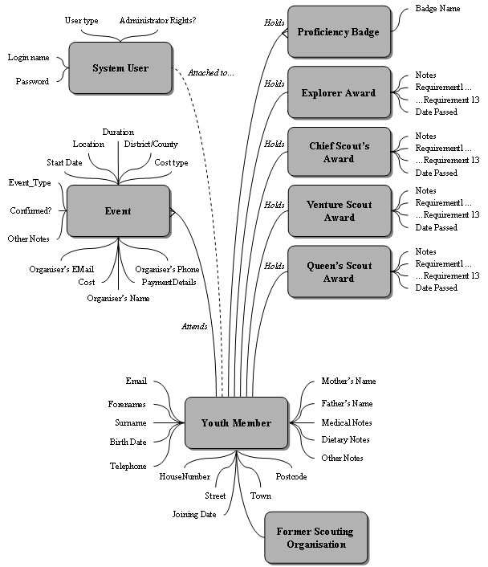
Figure 5-22 - Consolidated Entity-Relationship Model

The Former Scouting Organisation entity represents either:
- The Scout Troop of which this youth member was previously a part before joining the Explorer Scout Unit, or…
- The District that the youth member belonged to before moving to the Venture Scout Unit.
Of course, the youth member may have joined directly with no Scouting past.

Description of Minor Entities
Other entities in the system represent badges and awards. The Proficiency Badge entity represents badges given in real life for proficiency demonstrated in a particular ability, skill or pastime. The other entities represent the upper four stages in the Progressive Training Scheme, each of which has its own subsections (represented by its attributes).

Project Extension
To extend the system by adding an access control system, certain additional elements have to be included in the entity-relationship model. These include the System User entity and its attributes.
The optional relationship between the System User and Youth Member entities exists only if the user in question is in fact a youth member accessing the County system. In this case, we must attach their profile to their user account to allow them to view information about themselves when they do access the system.

Decomposition into Subsystem Databases
The model so far shows us the entities and relationships within the system where the system is regarded as a whole. At this point, we will also decompose the model into two to represent the County and District databases. This will help to emphasise the small but important differences between the two systems. Attribute differences between entities in the District and County systems are explained in Table 5-12.
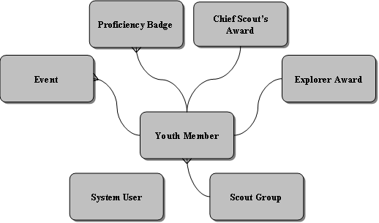
Figure 5-23 - District System Entity-Relationship Model

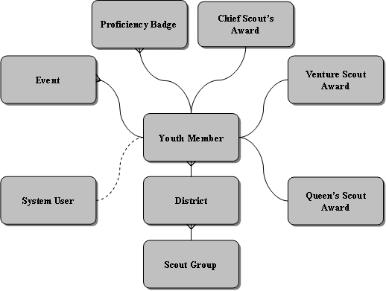
Figure 5-24 - County System Entity-Relationship Model

Difference | Explanation
Progressive Training Awards | Youth members can earn their Explorer Award only when they are in an Explorer Scout Unit. They can also begin work on (and possibly earn) their Chief Scout’s Award.  When they move to the Venture Scout Unit, they can continue to work on their Chief Scout’s Award but may then go on to earn the Venture Scout Award and Queen’s Scout Award.
System Users | Youth members cannot access the District system, and so there is no optional link in the District model between the System User and Youth Member entities.
Former Scouting Organisation | Youth members are recorded as having previously been a member of a Scout Group in the District model.  In the County model, they are recorded as having been a member of a District, each District being composed of many Groups.
Table 5-12 - Explanation of entity attributes

Relation Table Design
The next stage in designing the database is to translate the entities into a table representation. Table interdependencies are defined and tables reduced to third normal form to ensure data is not duplicated unnecessarily.

Figure 5-25 (page 52) and Figure 5-26 (page 53) show the table structure designed for the District and County systems, which differ in parts. At this stage, table names, the fields they contain and their keys have been decided on. Decisions on the types and lengths of the fields are made later on in the implementation phase.

Data Integrity Constraints – Problems and Solutions

As the diagrams show, referential integrity constraints are used throughout the table structure to help ensure anomalies do not arise. These constraints built in to the database mean that deleting items from tables in several cases will not be allowed. Although good practice, this can cause problems.

For example, every few years there is a national review of proficiency badges. Unpopular badges are removed from the badge book and new badges are introduced. Adding new badges to the Proficiency Badge table is not a problem, but we cannot delete badges if there is a youth member in our system who holds that badge.

For this reason, several tables have an Active Flag element that allows us to ‘activate’ or ‘deactivate’ rows in them. In this example, we could deactivate a particular proficiency badge, meaning it could not be awarded again in the future to anyone. However, data integrity would be maintained as the badge would not be removed from the table.

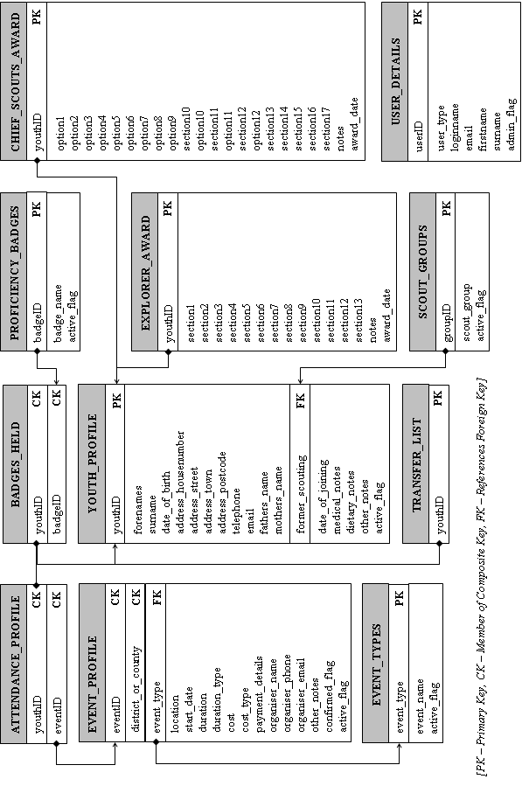
Figure 5-25 - District system relation table model

County ER Diagram Goes here
Figure 5-26 - County system relation table model

The Differences between District and County databases
The two systems contain a core set of tables, but certain tables exist uniquely in either the County or District system. These anomalies are explained in Table 5-13.

Table Differences
Table | District | County | Details
Transfer List |  |  | This table, which holds the ID numbers of youth members waiting to be transferred to the County system, is only present in the District system. This is because youth member records are transferred from Districts to County, not vice versa.
Districts |  |  | The County system contains a table listing all the Districts that exist within that County. The District system has no use for this, so the table is not included there.
Explorer Award |  |  | As mentioned earlier, youth members can only work for the Explorer award whilst in the Explorer Scout Unit (District level), and the Venture/Queen’s Scout Awards whilst in the Venture Scout Unit (County level).  They can begin (and possibly complete) work on the Chief Scout’s Award in the Explorer Scout Unit, and may carry on the award if uncompleted when they move to the Venture Scout Unit
Chief Scout’s Award
Venture Scout Award
Queen’s Scout Award
Access Requests |  |  | This table stores requests by youth members for access to the (County) system.
Event Sources |  |  | This table helps address the problem of sharing events across multiple databases. It keeps track of District events’ original ID number alongside a new ID number assigned them by the County system and the ID number of their originating District. The new ID number is guaranteed to be unique, and the duplication of events is avoided by making District systems check this table before transferring events.
Table 5-13 - Differences in table structure between District and County databases

Two tables in the databases are similar, but the County system adds additional fields over the District system. These differences are explained in Table 5-14.

Table Element Differences
Table | Difference | Explanation
Scout Groups | County system has an additional ‘District’ column | The maintenance of Districts and Groups within those Districts is done by the County. This additional column merely identifies which District the Group is in. The table’s key is also changed to be a composition of the district ID and the group ID.
User Details | County system has an additional ‘Matches Profile’ column | Youth Members are able to access the County system. To allow them to view a summary of information stored about them, their login accounts are linked to their profile.
Table 5-14 - Differences within tables between District and County databases

Project Extension
The access control extension to the project necessitates the storage of extra information. The Access Requests table in the County system stores requests by Venture Scouts for access to the system. An administrator examines the requests in the table via the interface and creates new user profiles for the Venture Scouts if necessary.
The User Type column of the User Details table categorises users into administrators, leaders and youth members. This allows the interface to direct users to the correct screens on login, and governs what operations they are allowed to perform on given tables in the database.

Section 5 Summary
This section detailed the modelling of the two databases for the District and County system variants. It then presented fully detailed table designs for the two databases, and diagrammed the relations that exist between those tables. The differences between the two databases were then fully detailed and justified.
Considerations of referential integrity were taken into account, and “active flags” added to several tables as a result, allowing records in those tables to be “deactivated” without actually removing them and violating integrity.

Interface Research and Design
One of (if not the) most important aspects of the project was the design and development of a good interface to the software. Bearing in mind the relatively low computer literacy of the end users, extensive planning and a sound methodology had to be followed to help ensure success.

Having chosen to use JavaServer Pages/Servlets as the interface technology, work began on designing and implementing an interface.

Design Inspiration and External Contributions

There were a number of sources from which inspiration for the interface design was drawn. The primary contributors are detailed here.

Scout Association Sources
The major changes in structure that gave rise to the need for this project are not the only changes that the Association has undergone. To complement the change in structure, a major re-branding of the Association nationwide has taken place. There are two main official sources for information on new design standards within the Scout Association that were used:

- ‘Brand New – A Guide to Our Visual Identity: Design Guide’
This publication is designed to help with the correct implementation of the Scout Association’s new identity. It advises on the use of logos and colours for stationery, banners, publications, etc… and so was very relevant to the project (Scout Association 2001a).

- ‘Brand New – A Guide to Our Visual Identity: Typography/Style Guide’
An extension to the above publication, this document provided technical information (hexadecimal colour codes, stationery templates, etc…) that was used in the system (Scout Association 2001b).

Other Internet Sites
The general format of all the screens in the system follows a consistent pattern. Essentially, the user’s attention is focussed on the central information-bearing area of the screen through use of surrounding white space.

The general layout of the screen was inspired by two commercial websites:

The Train Line website (TheTrainLine, 2002)

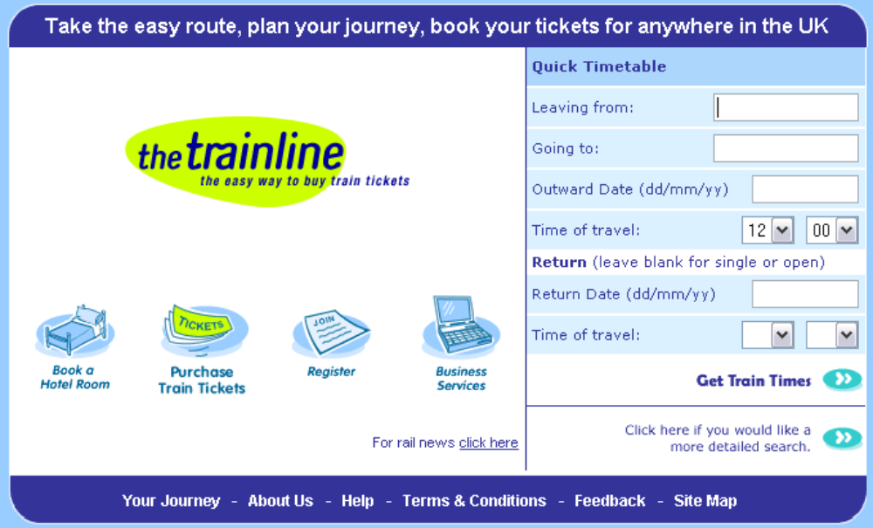
Figure 6-27 - 'The Train Line' website

The Train Line’s website is a popular and easy means of buying train tickets, and I have used it myself many times without problems. Some features I find especially good are:

- Maintenance of a constant colour scheme throughout, based on four colours.
- The placement of the navigational links at the bottom of the page and their persistence on every page.
- A centralised content window making good use of white space to make the site appear concise, simple and easy-to-use

This website’s design was influential, but more features were adapted directly from the design of the Jaguar X-Type website.

Jaguar’s X-Type website (Jaguar Cars, 2001)
(a screen shot is shown as Figure 6-28).

This website’s excellent visual design matches the Train Line in part, especially in the layout of options and navigation controls. I directly adapted three main features from this website into my own interface:

- Shape – The curved layout of the central information section is, in my opinion, very visually appealing. This is because of the site’s departure from the traditional straight-edged layout of windows and their elements.

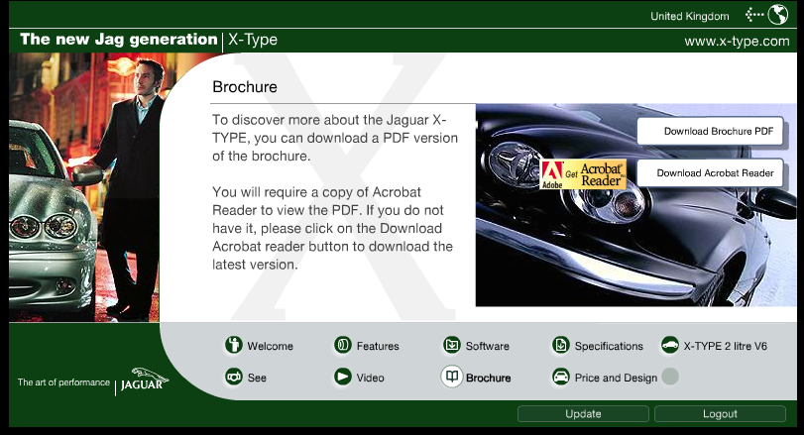
Figure 6-28 - Jaguar's X-Type Website

- Navigation Panel – The grey navigation panel at the base of the central section was included in my interface. Just as on the Jaguar website, it is present on virtually every screen and its content remains consistent throughout.

- Distribution of Information – Arraying non-critical and external links around the perimeter of the screen’s central information section.

Principles of Interface Design
In designing an interface, special consideration was given to Microsoft’s ‘Windows Interface Guidelines for Software Design’ (Microsoft, 1995). The guide ‘promotes good interface design and visual and functional consistency’ (Microsoft, 1995, xvii) and the points it makes have been applied to my interface where relevant. As the system was designed to be used on Windows-based computers, this was an ideal methodology. Examples of the application of the methodology’s principles are shown where appropriate.

User Control

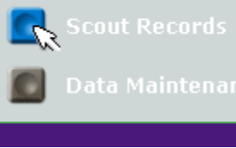  Figure 6-29 - Redundancy in Navigation Controls | click or drag-and-drop action.  Redundancy in controls is provided wherever possible to allow the user to make use of the software in his/her preferred way. An example of this is shown in Figure 6-29; the provision of both buttons and a standard combo box to allow navigation through the software

Directness
The software is designed so that users directly manipulate computerised representations of the stored information that are as familiar as possible. The system is, as detailed earlier, intended to replace the current paper-based means of tracking youth members and planning events.

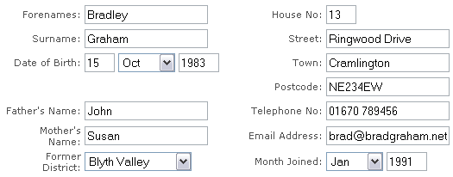
Figure 6-30 - The Youth Member Personal Details form

At a basic level, this means that the forms used to enter and retrieve information from the database are built to resemble the paper forms currently used, as is demonstrated in Figure 6-30. Thus the transfer of knowledge between the current and computerised record-keeping systems is made as straightforward as possible.

Consistency
A browser interface lends itself particularly well to maintaining consistency within the system. Several different techniques are used to achieve consistency:
- Cascading Style Sheets (CSS) – A common style sheet is applied to all screens in the system, which standardises font face, colour, size, etc…
- File Includes – Header and footer sections of the majority of screens are standardised by using includes. Basically, the same code is pasted at the top and bottom of scripts when they are served to the browser. For example, common features like the navigation buttons and combo box are implemented by using file includes.

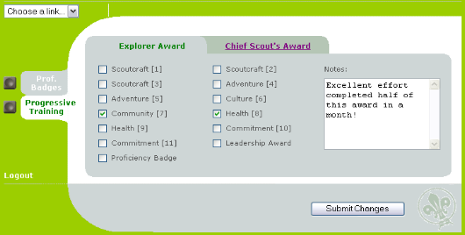 | 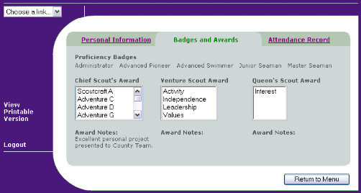
Figure 6-31 - Contrasting District (left) and County (right) Interfaces

The interfaces to the District and County systems are made consistent by sharing code and graphics between them. At a very basic level, the District system uses screens primarily coloured green (#99CC00) and the County system blue (#4D1979), as shown in Figure 6-31. This allows them to be instantly told apart, whilst still remaining consistent and familiar to all users, and adheres to the colour scheme recommended in the Scout Association’s design guidelines (Scout Association, 2001b).

Forgiveness
The interface takes into account the benefits of allowing users to learn by trial and error. Records for events and youth members are amendable. When irrecoverable changes are to be made, transferring a youth member from District to County or cancelling an event, for example, extra confirmation prompts are provided.

In addition to this, on every screen that allows entering, updating or deletion of stored information, a ‘Return to Menu’ button is provided. This allows the user to withdraw from the add/amend/remove action they are about to commit without performing any changes to the database at all.

Feedback
    Figure 6-32 - Button Rollover example | Where appropriate, feedback is provided to the user after they choose a particular course of action. Every button click (or drag-and-drop action on the navigation combo box) results in an immediate screen change. Another simple but important example of feedback is how the navigation buttons used throughout the system light up when the mouse moves over them, as shown in Figure 6-32.
  Figure 6-33 - Example of a Confirmation Prompt |  | Positive and negative feedback is also provided by the software whenever any change of information in the database occurs. This includes adding, amending and removing youth member and event records, and transferring information between District and County systems.

Aesthetics and Visual Design
Visual attributes of the interface communicate cues to the behaviour of objects. The design methodology says that ‘Well laid out screens are vital to making the software more pleasant to use’ (Microsoft 1995, p.7).

Throughout the software, important information is focussed in the centre of the screen, with secondary links and common navigation elements arrayed around the periphery. This can be seen in Figure 6-34, where the navigation combo box, logout and exit options are surrounding the central content of the screen.

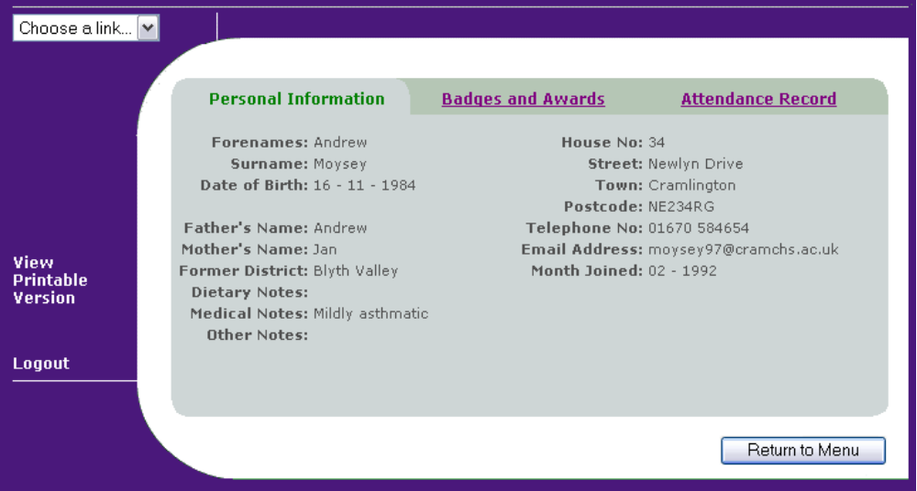
Figure 6-34 - Examples of Visual Design Features

Variations in background colour are also used:

- White backgrounds tend to contain ‘active’ content such as forms and information that the user is involved with editing directly.
- Grey backgrounds mostly contain buttons and menus used to navigate the software and alter the content of the ‘active’ sections.

Simplicity
The interface is designed with a shallow, broad structure; after login, the user is no more than three mouse clicks away from any functional element of the software. Principles of progressive disclosure are followed to lead users down straightforward paths to the task they wish to complete. An example of this is amending the details of an existing event:

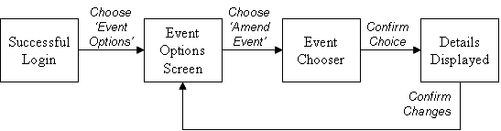
Figure 6-35 - Progressive Disclosure of Information from screen to screen

As can be seen in Figure 6-35, each action on the user’s part changes the screen to what the user would intuitively expect to see at each stage. The interface contains short, simple labels for all of its controls, avoiding clutter and potential confusion.

Section 6 Summary

In this section I have explained where the inspiration for the visual design and some of the features of the system’s interface came from, and the Scouting sources consulted. I then went on to describe how Microsoft’s ‘Windows Interface Guidelines for Software Design’ (Microsoft, 1995) influenced the development of the interface in seven areas:

- User Control – The user is active in triggering all transitions of the system
- Directness – The user directly manipulates representations of stored data
- Consistency – The interface is consistent in functionality and appearance
- Forgiveness – Data can be amended and updates cancelled
- Feedback – The system always prompts the user of success/failure of an action
- Aesthetics – The screens are laid out in such a way as to suggest their function
- Simplicity – The system is broad but shallow – it is easy to reach any part

Implementation Notes
In this section, the individual functional units of the system are described and explained. The name ScoutTrack was chosen for the software to reflect on its ability to allow records to “follow” youth members when they transfer Units.
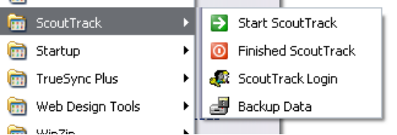
When a District system is installed on an Explorer Scout Leader’s PC, a program group is created with four shortcuts. These respectively stop and start the Mysql, Apache and Tomcat servers, direct the user to the login page and launch the database backup script (as described in section 8.3.2 on page 84).

Programming Conventions

Code Commenting

Java Code

Javadoc is Sun Microsystems’ tool for generating API documentation in HTML format from correctly formatted comments in source code. All servlets written directly (as opposed to those compiled from JavaServer Pages) are commented according to the JavaDoc guidelines, which can be found at http:// java.sun.com/ /j2se/javadoc/writingdoccomments/index.html. Examples include:

At the code level

/** Define some variables for later use in database access */
String username = request.getParameter("username");
ResultSet resultSet = null;

Within the code, brief comments are added frequently to explain the purpose of a variable, loop or other program construct.

At the method level

/**
* Processes incoming POSTed information via adding the forename,
* surname and email address of a youth member requesting access
* to the system to the ACCESS_REQUESTS table
*
* @param request HTTP request from the browser form
* @param response Output to the browser
* @exception IOException If an I/O problem occurs when
* running the servlet
* @exception ServletException A general exception a servlet can
* throw when it encounters trouble
*/

public void doPost
(HttpServletRequest request, HttpServletResponse response)
throws IOException, ServletException {

At the method level, a brief description of the method’s purpose is given. The nature of arguments the method accepts are explained, as are any exceptions that the method may potentially throw.

At the class level

/**
* A servlet to add a youth member’s request for system access
* to the database. Accessed directly from the login page
* (loginpage.jsp)
*
* @author: Paul Hudspith
* @version: Production
* @see: loginpage
*/

import java.io.*;
import javax.servlet.*;

public class CountyAccessRequest
extends javax.servlet.http.HttpServlet {

At the class level, a description of the role the class plays (in relation to other classes in the system) is given, as well as summary information about the current state of the class (Development, Testing, Production, etc…) and other classes related to it in some way.

HTML/JSP Code

Within JSP pages, commenting is done according to HTML standards, as the majority of the files are static HTML.

<body background="/images/background/central4.gif">

<!-- Put the header layer content here -->

<% if(!request.getParameter("what").equals("youthsummary")) { %>
<jsp:include page="includes/quickjump.htm" flush="true" />
<% } %>

<!-- Leave everything below here alone! -->

<!-- We need the scouttrack.youthrecords package
to extract ID numbers and names -->
<%@ page import="scouttrack.youthrecords.*" %>

As at the servlet code level, frequent, brief commenting helps organise the HTML into a more structured, readable form.

Code Style
The style of coding in the servlets was heavily influenced by ‘The Elements of Java Style’ (Vermeulen et al, 2000). This book provides a basic but comprehensive set of rules governing all facets of code-writing from indentation to white space to naming conventions.

User Access Control Features

Project Extension
The features listed here are the implementation of the idea to extend the project in order to provide a more secure environment for information storage.

Although hidden from the regular user, there is a complex access control system in operation within both District and County system variants, controlled by an administrator.

User Types and Privileges
At a basic level, there are four main types of user:

- Youth Member: A Venture Scout authorised to access the County system only to examine their records and the events calendar.
- Leader: A Venture or Explorer Scout Unit leader authorised to directly (ie. physically logging in) access either a District or a County system
- Remote Leader: An Explorer Scout Unit leader authorised to access the County system via the SynchTables or TransferYouth servlets.
- Administrator: A nominated leader who controls the provision of access to the other types of user. The administrator may also have a leader account.

A Remote Leader cannot visit the County system on the internet and login in through the normal means; his/her access privileges are restricted to synchronising reference tables and transferring youth members (as described in section 7.3).

To gain access to the system, a Venture Scout must first request access to the system (via the AccessRequest servlet). As shown in Figure 7-36, their request then appears on the Current Requests for Access list in the useradmin_addpage.jsp page. The administrator can examine this request (as shown) and then either assign a username/password that is communicated to the Venture Scout via email, or deny access and delete the request. Note that youth member accounts are matched to the relevant youth’s profile to allow access to their individual profile summary (see section 7.5.1 on 70).

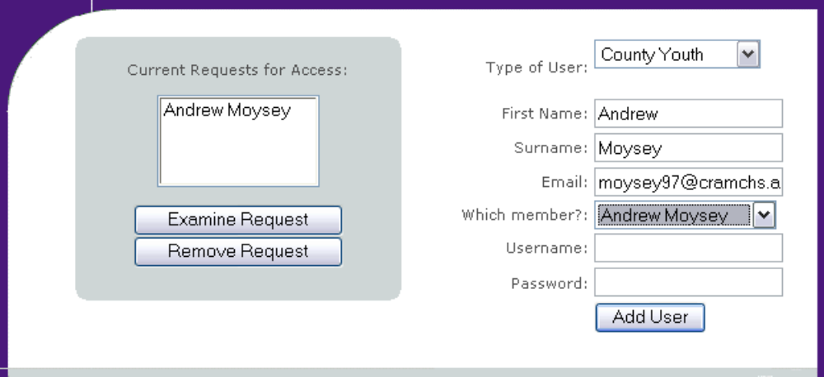
Figure 7-36 - Addition of a User Account

The addition procedure for other user types (ie. leaders) is similar, aside from the fact that they are not linked to a particular youth profile.

Enforcing of Access Controls
On login, username and password are checked against the database’s mysql.user table for authenticity. This table is provided directly by MySQL and covers all users authorised to access all databases hosted by that server. The system provides its own user_details table which stores email address, names, etc… for each user.

If the username/password combination is found to be authentic, the details are written to session cookies. These details do not, however, grant the user universal access to the database.

When the user accounts are created by the administrator, information is entered directly into the user_details table, but the mysql.user table also allows restriction of low-level database privileges. For example, Leader accounts are authorised to perform SELECT, INSERT, UPDATE and DELETE queries on the database tables, whereas Youth Member accounts may only perform SELECTs.

These restrictions provide an additional level of security. If, for example, a youth member attempted to access the database directly, they could not award themselves additional sections in progressive training awards, nor alter the contact details for other Scouts.

Youth Record Management Features
The primary role of the software is to administrate youth member records. The various tasks involved with that role are discussed here.

Adding, Amending, Removing and Transferring Records
All of these basic actions begin at the record_homepage.jsp script, and use variations on the same two-panel form, shown in Figure 7-37.

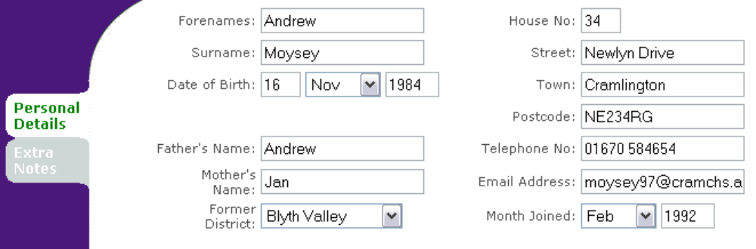


Figure 7-37 - Example Youth Member Record Form (County System)

The form appears empty if adding a new youth member record. When amending, removing or transferring a record, the form is populated with the details of the youth member you have identified in the previous selection screen. In the removing and transferring case, this is for confirmation purposes whereas when amending, the form can be updated and saved.

The only differences between the County and District versions of the form is the Former District combo box, which is Former Group in the District System variant.

Assigning Awards and Badges to a Youth Member
The other task related to youth member records is maintaining the record of their progress through the Progressive Training Scheme and the list of Proficiency Badges they have gained.

As can be seen in Figure 7-38, the form used here is of two-panel format. On the top panel, the awarding/removing of proficiency badges is carried out. Note that proficiency badges can only be awarded to Explorer Scouts and not Venture Scouts, hence the County system displays the badges already awarded.

The lower panel contains tabbed sections, one each for the Progressive Training Awards that can be earned in the Explorer or Venture Scout Unit. The numbered items correspond to those in the personal handbook issued to the youth members. Those named items (eg. ‘Scoutcraft’ or ‘Adventure’) indicate award sections where the youth member can choose one of many options, and a text box is provided to record which option they choose.

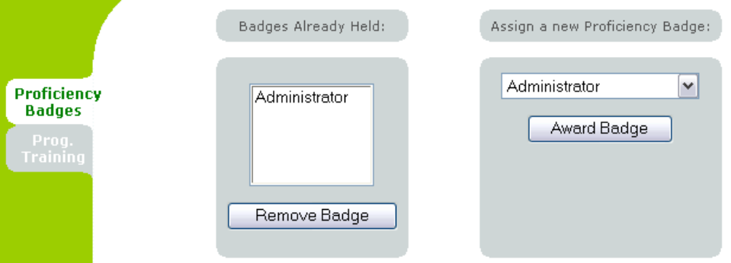

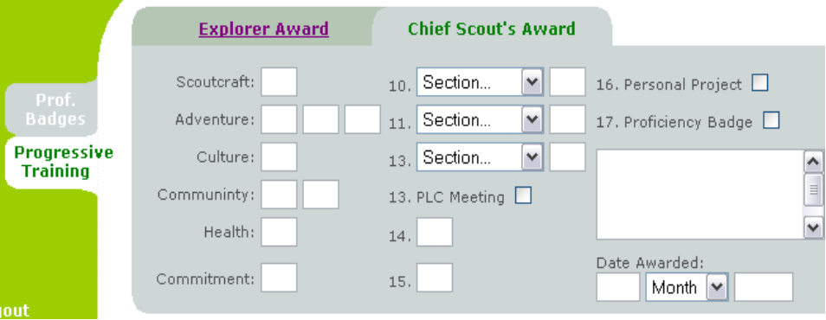
Figure 7-38 – Example Assignment of Awards and Badges (District System)

Event Management Features
The other core task of the system is to provide facilities to manage events such as camping trips, training days and meetings.

Adding, Amending and Cancelling Events
All of these basic actions begin at the event_homepage.jsp script, and use variations on the form shown in Figure 7-39. Notable points for events are

- Event Type: This combo box is populated from the event_types table in the database. This is one of the reference tables that is synchronised between District and County systems (see section 7.6.1).
- Confirmed: Only when an event is confirmed will it appear on the event calendar (see section 7.5.3) and be able to be transferred to other databases on synchronisation (see section 7.6.2).

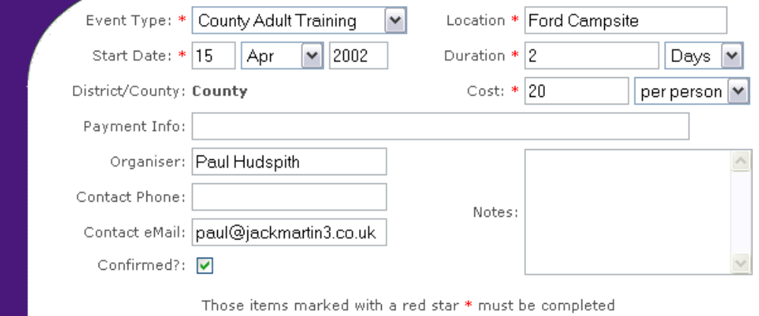
Figure 7-39 - Example Event Management Form (County System)

As for youth member records, the form is initially empty when generating a new event, and is populated when amending (so details can be changed) and cancelling (to confirm the correct event is being cancelled).

Recording Attendance at Events
Linking together records of events and youth members allows us to specify which youth members attended what events. The procedure here is to first choose a specific event, then add or remove youth members from the register of attendance for that event. This simple procedure is detailed in Figure 7-40.
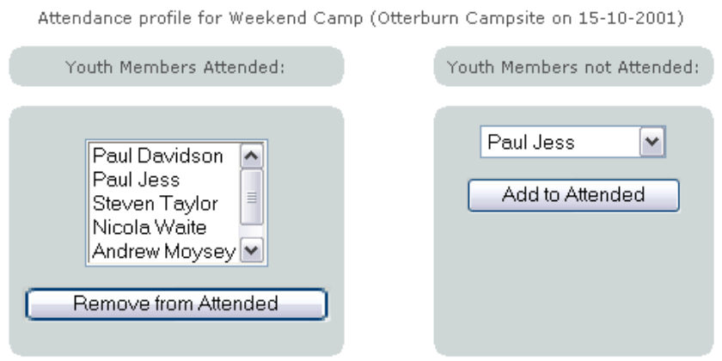
Figure 7-40 - Example Alteration of Attendance Records

Reporting Features

Project Extension
The features listed here detail the implementation of the project extension to include a common database application – producing meaningful summary reports from raw data stored in the system. Examples of printable reports can be found in Appendix D.

Although data can be extracted and summarised manually by opening multiple records and making notes, etc., it would be much more convenient and efficient if the system produced summaries automatically. Three types of reports were built in to assist with this.

NOTE: Venture Scouts with access to the system can view both the individual member summary for themselves, and the calendar of future events.

Individual Member Summaries
From the reporting menu page, the user identifies the youth member whose records they wish to summarise. They then proceed to the report_summary.jsp page, and are presented with a summary such as that shown in Figure 7-41. This summary effectively combines three system screens into one by being partitioned into three distinct panels. Each of these displays different types of information about the youth member: personal, award and attendance details.

A link labelled ‘View Printable Version” can be selected to produce a printer-friendly version of the summary, containing details from all three panels. An example of this printable report can be found in Appendix D.

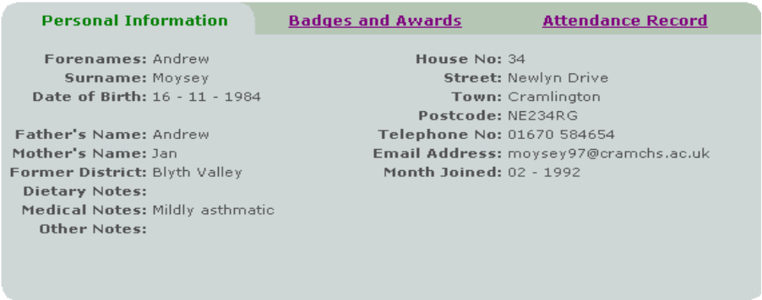

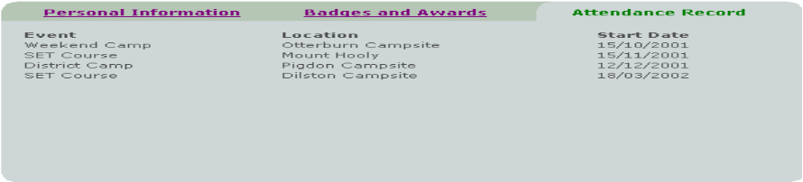

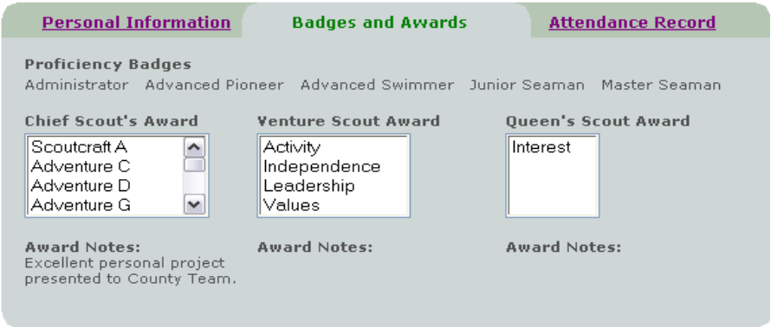

Figure 7-41 - Youth Member Summary Report

Attendance Registers
Although the attendances at any given event can be viewed by following the Record Attendances option in the events menu screen, a more easily accessible means is provided by the attendance register report. The user can initially define a date range (although it isn’t compulsory) in which events must lie, then at the click of a button loads all the attendance information for all events lying in that date range. By picking individual events from a combo box, they instantly open the attendance record for that event, as can be seen in Figure 7-42.

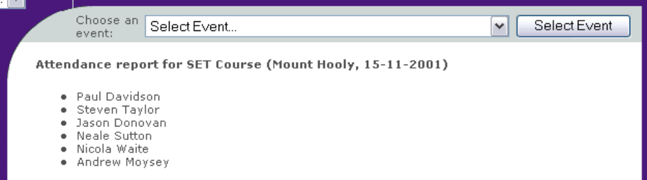
Figure 7-42 - Attendance Register Report

As in the case of the individual summary report, a printable version of the attendance register is available. This outputs a grid of all events matching the date criteria against all youth members, and either ticks or crosses the intersections depending on whether that youth member attended that event. An example of this printable report can be found in Appendix D.

Calendar of Future Events
The final report provided for is a summary of upcoming events. This is accessible by all users and simply shows a chronological list, starting with the earliest, of confirmed events upcoming, as shown in Figure 7-43.


Figure 7-43 - Event Calendar Report

Networking Features
Special accommodations had to be made to allow the synchronising and sharing of information between the multiple databases.

When a District system connects to the County system, its user must of course authenticate itself with a username and password known to the County system before carrying out any of the tasks described here.

Reference Information Sharing
So-called “reference information” includes tables of proficiency badges, types of event, Scout Group names and District names. In the distributed environment, all this information is maintained by the County system. District systems’ databases are updated whenever they connect to the County system.

This synchronisation first examines all the items in the Districts’ scout_groups, proficiency_badges and event_types tables and compares their active status to the County system’s equivalent tables. Any items in the Districts’ table that differ from the County’s can then be changed.

This would happen if, for example, a new book of proficiency badges had been released and some of the current badges had been removed. These now-defunct badges cannot be removed from the table, as this would violate integrity constraints if any Explorer Scout already held that badge. Instead, the badge is merely marked as inactive, meaning that it cannot be awarded again in the future to anyone.

After the status updates have occurred, a simple direct transfer of rows from the County to the District tables is attempted. The District database will reject any imported row of which it already has a copy, and accept any new rows that it doesn’t already have.

Event Sharing: The Problem and Solution
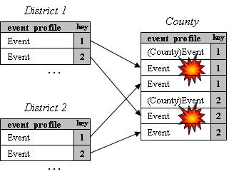
Figure 7-44 - The problems of sharing event information

Within the system, events are uniquely identified by an automatically generated numeric key in the event_profile table. As each District and County system variant is designed to be independently functional, this is a necessary feature.

However, when one or more District systems is used in conjunction with a central County system, an identity problem arises. This is demonstrated in Figure 7-44. Essentially, in the distributed system as a whole, multiple events exist with the same identifier.

Integrity rules in MySQL will not allow this to happen, and so will prevent the direct transfer of event information from the event_profile table in a District system to the event_profile table in the County system. The problem does not arise when a District system imports events generated by a County system. This is because events have a district_or_county flag in the event_profile table that makes up part of the key in the District database.

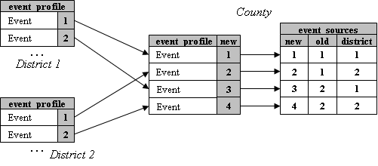
Figure 7-45 - The solution: provide new identifiers
The solution devised to meet this problem is as detailed in Figure 7-45. An obvious solution would have been to simply renumber events that were imported from Districts. However, the County system would have no knowledge of the original ID number of the event, and would import an exact duplicate every time events were synchronised.

By maintaining the event_sources table, we can avoid this problem. The event’s originating District is recorded#, and imported events are linked to their original, District-assigned identifier. When a District system connects, it can check this table (by selecting all rows flagged with its own District number) to see if it need transfer any of its events or not. Duplication is hence avoided.

Data Maintenance Features
The County system variant allows the maintenance of the four “reference” tables: proficiency_badges, event_types, scout_groups and districts. Any information updated in these tables is transferred to the District systems when they connect up and synchronise (see the previous section).

The form used to add and remove items from the tables is shown in Figure 7-46 (for the proficiency_badges table). The user simply enters the item they wish to add or remove, clicks the relevant button and the servlet then refreshes itself, with the relevant item added or removed.

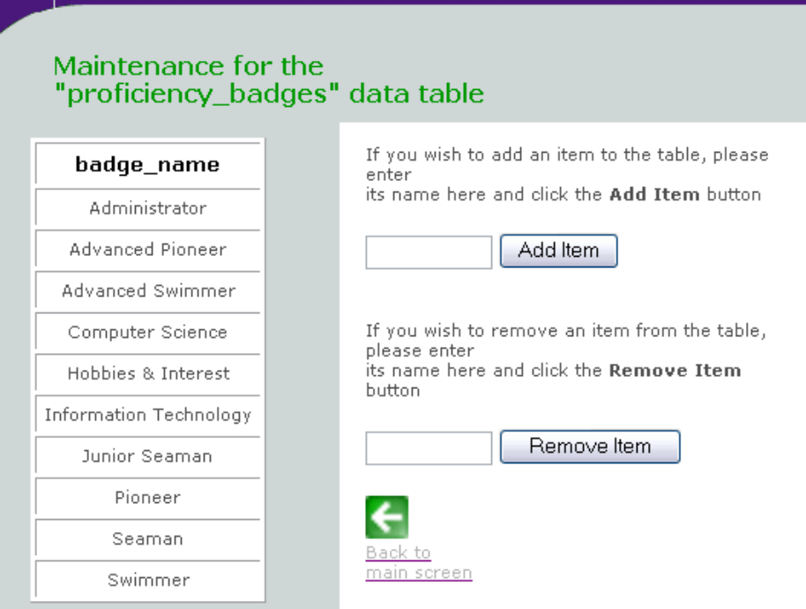
Figure 7-46 - Adding/Removing Items from Reference Tables

This raises an important point where referential integrity is concerned, as described in section 5.2.1 on page 51. If, for example, an Explorer Scout had been awarded proficiency badge A but in the new release of the badge book, A had been removed. A cannot be removed from the table, as this would violate integrity constraints.

For this reason, each of the tables has an active_flag column where the badges are marked either 0 (inactive) or 1 (active). When the user selects the “Remove Item” button, the system marks the relevant item as inactive and hence it is not shown on the list. When the user chooses to add an item, the system first checks if it is already in the table but is inactive. If so, it reactivates it (ie. changes its active status back to 1), otherwise it adds the item in a new row.

The scouttrack Servlet Package

? | Servlets vs. JavaServer Pages (JSP)  Essentially, Servlets and JSP are one in the same thing. JSPs are largely static HTML code filled with segments of Java code. When a JSP is requested by the web browser, it is compiled into a Servlet by the Java software on the server. The servlet is then run on the server, generating finalised HTML code containing data extracted from the database that is then served to the browser.  Servlets themselves may be written directly by the programmer, skipping the initial JSP stage. This approach is best suited to more complex situations, such as where much looping or conditional logic occurs in the code.

All of the servlets written directly (as opposed to being created automatically from JSP files) are grouped together in a package. Packages are a convenient way of organising work, and distinguishing ‘homemade’ classes and methods from external code libraries. The package is called scouttrack, and is subdivided into six sections. Some of these sections contain two variations of the classes shown in the hierarchy above. This is because of the slightly different functionality required for District and County system variants.

+-- scouttrack
+-- choices
+-- ChooseDate
+-- FindItem
+-- events
+-- Event
+-- EventMethods
+-- County/DistrictAssignAttendance
+-- transfer
+-- SynchTables
+-- TransferFlag
+-- TransferRecord
+-- users
+-- CountyUserMethods
+-- AccessRequest
+-- User
+-- utils
+-- GeneralMethods
+-- CookieMethods
+-- QueryMethods
+-- LoginTest
+-- Redirector
+-- TableMaintenance
+-- TableMaintenanceGroups
+-- youthrecords
+-- County/DistrictAssignAward
+-- County/DistrictRecordMethods
+-- YouthRecord

The names of the package sections are indicative of what tasks the classes in those sections are designed to do. More specifically:

- scouttrack.choices contains generic servlets that allow the user to pick options, for example a youth member or event when intending to modify them.
- scouttrack.events allows the creation/updating/storing in the database of Event objects, as well as the servlet handling attendance recording.
- scouttrack.transfer (used by the District system) governs all connections between the local and remote databases including synchronising reference tables, flagging youth members as being ready to transfer and actually transferring them.
- scouttrack.users (used by the County system) allows the creation/updating/ storing in the database of User objects when altering user access accounts.
- scouttrack.utils contains the majority of general-purpose classes that are used in database connection, reading from/writing to cookies, maintaining reference tables (County system only) and authenticating at login
- scouttrack.youthrecords allows the creation/updating/storing in the database of YouthMember objects, as well as the servlet handling award assignment.

Site Maps
The site maps show how all the JSPs and servlets in the system interact, and how the user navigates around the system. Only servlets that are used directly in the browser are shown. Background classes and servlets (such as those that control database access in scouttrack.utils) are not shown.

Key

 | JavaServer Pages are denoted by this icon. |  | Objects are represnted by the ring, with their class names adjacent.
 | Servlets are represented by the cross, with their class names adjacent. | 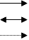 | Arrows represent the transitions between JSPs/servlets in the site.

District Site
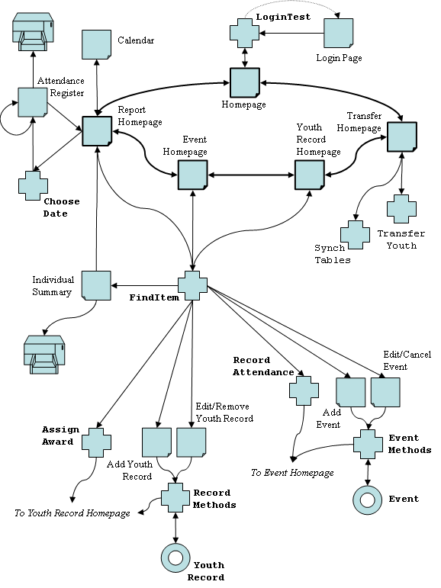

Figure 7-47 - Site Map of the District System Variant

County Site Map Goes Here

Figure 7-48 - Site Map of the County system variant

Section 7 Summary

In this section the transition from the research, modelling and design of all aspects of the system to an end solution was made. The software was also given a name, ScoutTrack.

The solution was broken down into its functional parts, and these parts were then described individually:

- Access Control using custom tables and the database’s own user table to restrict access to functions depending on a user’s rights.
- Youth Record Management allows addition, amendment and deletion of user records, as well as maintenance of their award history and achievements.
- Event Management allows addition, amendment and deletion of events and activites, as well as recording youth members’ attendances at these events/activities.
- Reporting gives leaders the ability to generate summaries of data stored in the database on topics including attendance, future events and youth member summaries.
- Networking allows the transfer of information and records between District and County versions of the system via the internet.
- Data Maintenance makes the system adaptable to future changes by making reference tables in the database amendable.

The section goes on to describe and explain the components that make up the package of Java Servlets written to carry out both routine and complex tasks in the system.

Finally, maps of all the possible transitions between JSPs and Servlets in each of the District and County systems were provided to demonstrate the shallow nature of and ease of navigation through the system.

Software Testing

Testing Programme
As with any software, the code was rigorously tested as the development was underway. More cohesive testing of the system as a whole was performed in weeks 17 and 18 of the project, when the system was demonstrated to be following pre-prepared scripts of its expected behaviour.

Certain common testing issues such as “stress” testing the system (ie. with heavy simultaneous use by multiple users) are not relevant to this project, as there is expected to rarely be more than one user using the County system at any given time. Given that there are documented cases on MySQL’s website of tens of thousands of users using MySQL applications simultaneously, I think that my database should remain stable under its much lower user load.

Post-development Testing
For the purposes of running an initial round of tests on the system, the actual usage environment was simulated as closely as possible. I used my laptop computer as the standalone machine running the District system, and my PC (with broadband internet connection) to act as a web server running the County system. Connectivity between the two was achieved in development using a direct LAN connection. During testing, the LAN was disconnected and instead the laptop used a modem to connect to the internet. This mirrors the end user environment for operation of the system.

Operating with empty databases
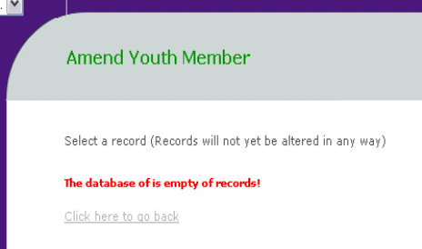
A “special case” built into a lot of the servlets is to cope when a SELECT query returns an empty ResultSet. This happens in several parts of the system when it is first installed and the database contains little or no data. The first round of testing was to check that all SQLExceptions thrown when trying to loop through an empty ResultSet are caught and dealt with correctly.
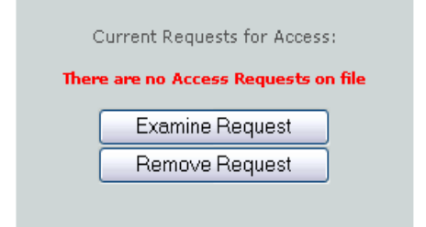
To test these features, the District and County databases were emptied of all data, save for the administrator’s user account. A lot of scripts and servlets had to be tested as they contain combo boxes populated from database tables.
Figure 8-49 - Dealing with an Empty Table
This test revealed that the system functioned exactly as expected, presenting relevant, informative error messages to the user when the database table in question was found to be empty. Some of these error messages are demonstrated in Figure 8-49, where the user is trying to amend a youth record (top) and where the administrator is adding a new user (bottom).

ISSUE | Creating a new Event  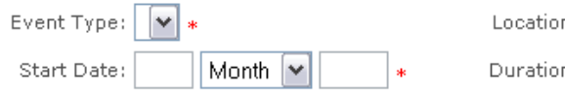  When creating a new event, the form opened with the Event Type combo box empty. This is to be expected, as the event_types table was empty. However, the form should not have opened as any submission of details would be rejected by the database as the Event Type field is compulsory.  This was resolved by amending the FindItem servlet to prompt the user to input some event types via the maintenance screen before allowing them to proceed.

ISSUE | Creating a new Youth Record  A similar problem to that detailed above was found. The Former Troop (District) and Former District (County) combo boxes are populated from the scout_groups and districts tables, and appeared empty on the form. Although they are not compulsory fields, this is still a problem. Again, the FindItem servlet was altered to check for this and prompt the user if there is a problem.

Checking Consistency of Information Throughout the System
The next stage in the testing involved populating the database through the interface and checking that information entered was correctly retrieved everywhere that it was used. For example, when an event is created its details should not only reappear correctly in the “amend event” screen, but it should appear in the right place on the calendar, be available when altering attendance records, etc…

This sort of testing was carried out for events, youth member records, attendance records, awards and badges and the system proved to be totally reliable when storing and retrieving.

ISSUE | Attendances at Future Events  When carrying out this testing, one not-so-obvious problem came to light involving the recording of attendances at events. When choosing the event for which the user wants to alter attendances at, the combo box displayed a simple list of all events in the database.  Of course, you cannot attend an event that has not happened yet, so the FindItem servlet was altered to show only events starting on or before the current date when choosing an event to modify attendances at.

User Acceptance Testing
This was an important stage in the project for a number of reasons:

- It was the first time the end users had come into contact with a fully functional version of the software
- It was the first time a copy of the finished system had been completely installed from scratch on a new machine
- Real information would be entered into the system and it was important to show the system was solid and reliable to reassure the users

All aspects of the system were tested, including the networking feature. I had left my home PC acting as a web server by running Apache, Tomcat and MySQL, all connected to the internet via my broadband cable modem.

The User Testing
I took a step back from the users, trying to get them to learn the use of the system by trial and error, and by using the user manual I had prepared. No great problems were encountered by any of the three users involved in the testing. They were all, of course, already familiar with all the Scouting terminology used on the site and commented favourably on:

- Speed: The system was always quick to respond to any button click or link selection, even on the 333Mhz test machine we were using.
- Ease of use: Comments were made that the system was well structured and that tasks of a similar nature were grouped together well.
The users’ main concern was when records were transferred to County. Although the system functioned as expected, and provided feedback to the users informing them of the successful transfer, they still held doubts about it. They could see that the records had effectively vanished from their system, and I showed them that by logging in to the County system running on my PC, we could verify that all the records had been transferred. This reassured them.

Data Backup
Another area that the leaders expressed concern about (and one brought up earlier at the time of the project presentation) was that of data backup. If this electronic system is to totally replace the paper-based record-keeping currently used, then some provision for backup is a necessity.

Fortunately, MySQL provides an in-built data dumping facility that backs up all information in all database tables when invoked. A simple executable script run from the ScoutTrack program group on the Windows Start Menu performs this data dump, updating the backup records every time it is run. An automatic restore script has not been provided, to save any potential overwriting of data entered since the last backup if it was run accidentally.

Conclusions & Future Suggestions

Did the Project Meet its Objectives?

In order to answer this question sufficiently, each of the nine objectives laid out in the Specification on page 12 will be analysed individually.

1. Specify as precisely as possible the desired capabilities of the system
A complete and comprehensive specification was written, then discussed with and accepted by the project supervisor. Changes made since formal submission of the specification were also discussed and agreed on. The original specification can be found in Appendix A, the revised specification in section 2.
2. Produce a detailed, unambiguous design for the system using UML
Great effort was put in to producing a coherent design for the software, as its use was clearly demonstrated in the 2nd year Software Engineering course. As well as the UML work found in section 3, a complete step-by-step breakdown of all use cases was performed (see Appendix B).
3. Implement the District sub-system for Youth Member management.
4. Add functionality for handling event management
Having chosen and designed a database and browser interface for the software, a working system was implemented to handle both Youth Members and Events.
5. Produce a modified system variant to function as the County system
Some relatively straightforward modifications were made to copies of all the interface scripts and servlet code to satisfy the slightly different requirements for a County system.
6. Implement the database communication facility for Youth Members
7. Add ability to synchronise events/reference tables between the databases
Electronic transfer of youth member records is supported, as is the transfer of tables of event types, proficiency badges and Scout Groups from the County to District systems.
8. Perform rigorous, documented testing on all parts of the system
This testing that was carried out to produce a stable, error-free system is documented in chapter 8.
9. Produce user documentation and reference material
The User Manual produced is included with this report, and all the design reference material appears in earlier sections.

In summary, the project has met all the objectives given it by its specification. In addition to these objectives, additional functionality has been added to further increase its usefulness and usability:

How the Project Grew Beyond its Objectives

Two major avenues were followed in extending the project beyond its initial specification, namely the addition of user access control and administration functionality, and the ability to produce reports from data stored in the database. These extensions have been flagged throughout the report in grey “project extension” boxes.

Access Control and Administration
The assessor’s critical comment on the mid-project progress report submitted in December 2001 was “no mention of security”. Following this recommendation, I developed, using the existing interface, the ability for an administrator to maintain the user accounts of those authorised to access the system (both directly and remotely). This not only restricted what appears in the browser to the user, but also restricts their rights to alter the database tables, as is explained in 7.2 on page 65.

Report Generation
A common use of database systems, to generate reports from the data they store, was also developed. The youth member summary report (an example of which can be found in Appendix D) crosses many database tables to combine all the information held about any given youth member. The events calendar provides a useful diary of upcoming events, and the attendance register allows leaders to identify youth members with good or poor attendance records. Development of this feature is described in section 7.5 on page 70.

What Additional Features could be Added?

Over the course of the development, several ideas for useful extensions to benefit both the developer and the user came to mind.

More Integrated Administration
An ideal extension would be to make the system further reduce the administrative load on leaders. For example, records of particular events have to be maintained in a certain way (as the system shows). However, for certain adventurous activities and events permission has to be sought from the relevant Scouting authority using particular forms. An example would be the the “Permission to Camp” form that has to be submitted to both the District Commissioner of your District and of the District you intend to camp in.

Whilst recording the event information in the database, the system does not support generation of printable forms from that data (save for youth member summary and attendance reports). The system could use the template of the “Permission to Camp” form, for example, to generate a printable form populated with event data from the database. They could then be merely dropped in the post box and sent, saving time otherwise spent filling out duplicated information on the form by hand.

Other relevant examples include forms requesting the awarding of the Queen’s Scout Award (which requires an interview with a suitably senior leader) or the annual subscriptions submission (which includes details for all youth members for insurance purposes).

Certificate Generation
The system records information on youth members’ progress through the Progressive Training Scheme, including the dates on which certain awards were issued. A simple but desireable extension could use this information to produce a certificate for the youth member, stating their personal details, achievement and the award date.

System Event Log File
From the viewpoint of one who will be called on to maintain the system in future, the idea of an event log file appeals to me. By this I mean JSPs and servlets writing lines to a simple text file when they perform actions. For example…

...
24-10-02 14:38 RecordMethods servlet
Member 23(James Brown) details edited

24-10-02 14:42 AssignAward servlet
Member 12(Andrew Green) awarded Athlete badge

24-10-02 14:43 AssignAward servlet
**ERROR** when updating (ArrayOutofBounds Exception)
...

If reporting a problem or error, by noting down the system time and what they were doing at the time the problem/error can be located and more easily rectified.

References, Acknowledgements & Glossary

General Bibliography

Bhamidipati, K (1998), SQL Programmer’s Reference, McGraw-Hill, Berkeley, CA

Birnam, Stewart (2001) Distributed Java 2 Platform Database Development, Prentice-Hall, Palo Alto, CA

Buser, D, Kaufmann, J, Llibre, J, Francis, B, Sussman, D, Ullman, C & Duckett, J (2000), Beginning Active Server Pages 3.0, Wrox Press, Birmingham, UK

Castro, Elizabeth (2001), Perl and CGI for the World Wide Web, Second Edition, Peachpit Press, Berkeley, CA

Hall, Marty & Brown, Larry (2001) Core Web Programming, Second Edition, Prentice-Hall, Palo Alto, CA

Horstmann, Cay & Cornell, Gary (2001) Core Java 2: Volume 1 – Fundamentals, Prentice-Hall, Palo Alto, CA

Negrino, Tom & Smith, Dori (1999) JavaScript for the World Wide Web, Third Edition, Peachpit Press, Berkeley, CA

Priestley, Mark (2000) Practical Object-Oriented Design with UML, McGraw-Hill International, Maidenhead, Berkshire, UK

Preece, J., Rogers, Y., Sharp, L., Benyon, D., Holland, S. & Carey, T (1994) Human-Computer Interaction, Addison-Wesley, Wokingham, UK

Scout Association (2001a) Brand New: A Guide to Our Visual Identity (Design Guide), Scout Association, Chingford, London [this document is available online at http://www.scoutbase.org.uk/library/clipart/logos/new/design_guide.pdf]

Scout Association (2001b) Brand New: A Guide to Our Visual Identity (Typography and Style Guide), Scout Association, Chingford, London [this document is available online at http://www.scoutbase.org.uk/library/clipart/logos/new/design_manual.pdf]

Ullman, Larry (2001), PHP for the World Wide Web, Peachpit Press, Berkeley, CA

Referenced Literature and Sources

References have been prepared in accordance with the Harvard Style guide, information on which can be found at http://www.lib.monash.edu.au/vl/cite/harvex.htm.

Apache (2002 © 1999-2002 The Apache Software Foundation) “Apache HTTPD Project” (Apache Software Foundation), Available: http://www.apache.org (Accessed 2001/2002)

Ferguson, Scott (2001, © 1998-2002 Caucho Technology, Inc) “JSP vs mod_php and mod_perl”, (Resin: Developer Source, XML Application Server), Available: http://www.caucho.com/articles/benchmark.xtp (Accessed: 2001, November 7)

Hall, Marty (2001), Core Servlets and JavaServer Pages, Prentice-Hall, Palo Alto, CA

Harms, David (2001), JSP, Servlets, and MySQL, Hungry Minds Inc., New York, NY

Jaguar Cars (2001 © Jaguar Cars 2001) “Jaguar X-Type” (Jaguar X-Type), Available: http://www.x-type.com (Accessed 2001, November 26)

Jakarta-Tomcat (2001 © 1999-2000 The Apache Software Foundation) “Tomcat-Apache HOWTO” (Tomcat Documentation), Available: http://jakarta.apache.org/tomcat/tomcat-3.2-doc/tomcat-apache-howto.html (Accessed 2001, November 11)

Jepson, Brian (2001, © 1996-2002 CMP Media LLC) “PostgreSQL vs. MySQL: Building better databases”, (New Architect), Available: http://www.webtechniques.com/archives/2001/09/jepson/ (Accessed: 2001, November 3)

Lim, John (2000, (c) 2000-2002 John Lim) “7 Reasons Why PHP is Better than ASP”, (PHPEveryWhere), Available: http://php.weblogs.com/php_asp_7_reasons (Accessed: 2001, November 2)

Lim, John (2001, © 2000-2002 John Lim) “Comparing PHP with Perl for Dynamic Web Pages”, (PHPEveryWhere), Available: http://php.weblogs.com/php_versus_perl (Accessed 2001, November 4)

Microsoft (1995), The Windows Interface Guidelines for Software Design, Microsoft Press, Redmond, WA

Netcraft (2001 © Netcraft 2001) “Market Share for Top Servers Across All Domains” (Netcraft Web Server Survey), Available: http://www.netcraft.com/survey/ (Accessed 2001, December 10)

Oracle Underground (2002, © 1995-2001 The Oracle FAQ) “Oracle FAQ: PL/SQL”, (Oracle Underground Frequently Asked Questions), Available: http://www.orafaq.com/faqplsql.htm (Accessed 2001, November 6)

Perdue, Tim (2000 © 2002 INT Media Group) “MySQL and PostgreSQL Compared” (PHPBuilder.com), Available: http://www.phpbuilder.com/columns/tim20000705.php3 (Accessed 2001, November 8)

TheTrainLine (2002 © 2002 Trainline.Com Limited) “TheTrainLine: train times, book tickets, reserve seats for UK trains” (TheTrainLine), Available: http://www.thetrainline.com (Accessed 2001, November 20)

Vermeulen, A., Ambler, S., Bumgardner, G., Metz, E., Misfeldt, T., Shur, J. & Thompson, P (2000) The Elements of Java Style, Cambridge University Press, Cambridge, UK

Acknowledgements

 | John Harvey  District Commissioner  Original inspiration for the project, advisor on changes in the Movement and software testing. |  | Malcolm Christie  Explorer Scout Leader  Software testing
 | Chuck Waite  Venture Scout Leader  Software testing

- The Sybase name is a trademark of Sybase, Inc., Dublin, CA
- The Oracle name is a trademark of Oracle Corporation, Redwood Shores, CA
- The Windows, Access and SQLServer names are trademarks of Microsoft Corporation, Redmond, WA
- The Java name and logo are trademarks of Sun Microsystems, Inc., Palo Alto, CA
- The PostGreSQL name and software is © 1996-2000, PostgreSQL, Inc and © 1994-1996 Regents of the University of California, all rights acknowledged
- The MySQL name and software is © 1995-2002 MySQL AB, all rights acknowledged

Glossary of Scouting Terminology

The Scout Association, like any other large organisation, has its own organisational structure and terminology for various people, groups, events, etc... This glossary explains the meaning of the most frequently used terms.

NOTE: Underlined items are defined elsewhere in the glossary.

County
The collective term for a number of Districts that are located in a similar part of the country (‘Warwickshire’ and ‘Northumberland’ are Counties). Generally organized along the boundaries of a County Council.

Cub Scout
The young (aged between 8 and 10½ years) members of a Cub Scout Pack.

Cub Scout Pack
The collective term for both the Cub Scouts and Cub Scout Leaders within a Scout Group (the name comes from the collective noun for wolves; Cub Scouts were originally known as “Wolf Cubs” at their creation in the 1920s).

District
The collective term for a number of Scout Groups that are located within a broadly similar area (‘Coventry’ and ‘Leamington Spa’ are Districts) and are administrated for by the same body. Generally organized along the boundaries of a Borough Council.

Event
A ‘Scouting Event’ can cover a wide range of activities including (but not restricted to) camping, skills training, sports, meetings, hikes, quizzes, etc…

Explorer Scout
The young (aged between 14 and 18 years) members of an Explorer Scout Unit.

Explorer Scout Unit
The collective term for the group of Explorer Scouts and their Leaders within a District.

Leader
Any adult member of the movement, except Venture Scouts. Can be active within a Cub Scout Pack, Scout Troop, Explorer Scout Unit or at District or County level.

Proficiency Badge
Proficiency Badges are awarded to Cub Scouts, Scouts and Explorer Scouts for demonstrating a particular skill or ability (e.g. Badges are available for swimming, computer skills, mountaineering, seamanship and many other subjects).

Progressive Training Awards
Stages in the Progressive Training Scheme. The four upper stages are provided for in the system, these being (in order) the Explorer Award, the Chief Scout’s Award, the Venture Scout Award and the Queen’s Scout Award.

Progressive Training Scheme
The ongoing training of all Youth Members. The scheme is a programme of requirements in a broad range of subjects including community service, adventurous activities and personal development. Individual stages in the scheme are known as Progressive Training Awards. The scheme is roughly comparable in nature to the popular Duke of Edinburgh’s Award programme.

Scout
The young (aged between 10½ and 14 years) members of a Scout Troop.

Scout Group
The constituent elements of a District, usually containing a Cub Scout Pack and a Scout Troop (e.g. the ‘2nd Leamington Spa Scout Group’).

Scout Troop
The collective term for both the Scouts and Scout Leaders within a Scout Group.

Venture Scout
The members of a Venture Scout Unit, aged between 18 and 25 years

Youth Member
A broad term covering Cub Scouts, Scouts, Explorer Scouts and Venture Scouts in the context of this project.

Appendices

Appendix A: Original Specification

The Problem

In April 2002 the Scout Association will be totally reorganised from its present system of four “sections” (essentially age bands) into a new five-section form. In addition to the altered age ranges, the level at which youth members will register is to be altered. This is best demonstrated in a diagram:

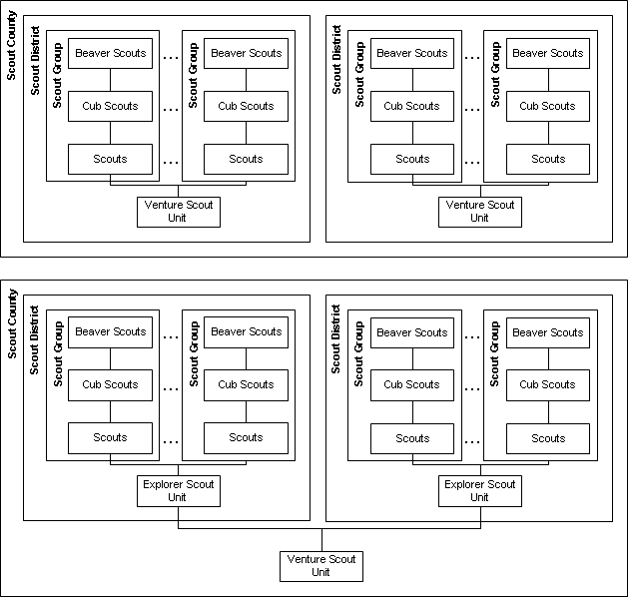

- A Group contains many Sections
- A District contains many Groups and will have an Explorer Scout Unit that draws its members from the various Scout sections of its groups
- A County contains many Districts and will have a Venture Scout Unit that draws its members from the various Explorer Scout Units of its Districts.

In order to help co-ordinate this change, and to aid the process of keeping track of youth members after they are de-centralised at age 14, my County (Northumberland) has identified the need for some sort of database.

Objectives

- Specify as precisely as possible the desired capabilities of the system
- Produce a detailed, umabiguous design for the system using UML
- Implement the localised District sub-system (primarily using Java) for Youth Member information.
- Add functionality to the District sub-system for handling event management
- Implement the County sub-system (primarily using Server-side scripting) for Youth Member information
- Add functionality to the County sub-system for handling event management
- Implement the cross-communication facility for Youth Member information
- Add functionality to perform cross-database communication of events
- Perform rigorous, documented testing on all parts of the system
- Produce user documentation and reference material, and final report

Functionality

The desired finished project will consist of three major functional parts:

The District-level Database sub-system
- A browser-based GUI interacting with a MySQL database as its data source via JDBC embedded in Servlets and JavaServer pages.
- Designed to be an independently functional system running on a standalone Windows-based PC.
- Will store information including personal details, scouting history, awards and event attendance for youth members in the Explorer Scout section.
- In addition, will provide a tool to manage events (training, camps, visits, etc…) within the District.

The County-level Database sub-system
- Designed to be used (in different ways) by adult and youth members of the County’s Venture Scout Unit.
- Another, similar browser-based interface to MySQL, this time hosted centrally on a public web server.
- Again, information will be stored about Youth members and events. Here, Youth members will be able to connect to the website and view a diary of events which may be of interest to them.
- Leaders will be able to locate youth members based on their skill set for invitation to events, training requests, etc…

The Cross-Database sub-system
- To reduce administrative overheads required for normal operation of the two separate databases described, an application which links the two is desireable.
- Multiple District databases should be able to connect up to a single County database via the internet. I hope to implement the functionality to “virtually transfer” youth members from the District databases to the County database when they physically transfer Units at age 18.
- The design/realisation of this part will require significant research, but I expect to use a combination of JDBC and java.net to implement it.

Timetable

Week | Objective
2 | Hand in draft Specification
3 | Finalise Specification, Begin UML Use Case Model
4 | Complete Use Case Model, Begin Static Model
5 | Complete Static Model, Dynamic Model
6 | Finalise and combine UML design elements
7 | Database design, modelling and creation
8 | Background research into Servlet/JSP implementation
9 | Web interface design and production
10 | Further coding of JSP/Servlets to support interface
Xmas | Complete District subsystem to operable state
11 | Find a host and build a suitable environment for County subsystem.
12-13 | Research into methods of linking the databases
14-16 | Database interface coding
17-18 | Testing and documentation
19 | Preparation for presentation
20 | Presentation, Commence final report
Easter | Finalise report and documentation
21 | Hand in report
Resources
- The District sub-system will primarily be developed on my home PC using Borland's JBuilder and MySQL (along with some sort of database query tool).
- The cross-database communication sub-system will again be developed using JBuilder at home on my Windows PC.
- The County sub-system will be server-hosted. My home PC is set up with the Windows XP Professional OS, incorporating Apache's HTTPD web server and Tomcat JSP server.. This, combined with my broadband connection to the internet @ 64kbps allows it to provide functionality as a testing environment, but vulnerability of using one machine for all the work means I will make use of my departmental web space to host the County database and website.
Backup will be performed on a regular basis both locally using my LS-120 SuperFloppy disk drive and CD-Writer. Offsite, I plan to regularly backup my work onto servers both at the Department and at NTL (personal space) via the internet.

Appendix B: Complete Use Case Analysis

Generic Use Cases for DistrictLeader and CountyLeader

These use cases detail all the tasks that can be carried out on either the County or District systems by DistrictLeader or CountyLeader users (referred to as Leader in these analyses). Additional use cases for these actors are listed in

AddYouth Use Case
Summary: Leader adds a youth member record to the system
Preconditions:
- System is idle, displaying the menu screen
Process:
- Leader chooses to add a youth member to the database.
- System prompts the Leader for personal information about the youth member (names, address, phone…).
- System prompts the Leader for information about the member’s scouting experience/history (awards, previous group, etc…).
- Leader submits the information to be stored.
- System generates new database record for the youth member and provides visual confirmation of this.
Alternatives:
- If any information entered fails validation, Leader is prompted to amend the information before it can be entered in the database.
Postconditions:
- A new youth member record has been successfully created in the database.

AmendYouth Use Case
Summary: Leader amends information for an existing youth member
Dependency: Includes OpenYouth use case
Preconditions:
- System is idle, displaying the records of a youth member
Process:
- Includes OpenYouth use case
- Leader modifies the youth member’s details.
- Leader confirms correctness of modified information
- System alters records for the youth member and returns to the menu screen.
Alternatives:
- If any modified information entered fails validation, Leader is prompted to amend the information before it can be altered in the database.
- Leader chooses (at the confirmation phase) not to amend the member’s records. The system then returns to the menu screen.
Postconditions:
- Youth member’s records have been correctly updated

RemoveYouth Use Case
Summary: Leader removes a youth member from the system
Dependency: Includes OpenYouth use case.
Preconditions:
- System is idle, displaying the details of one youth member
Process:
- Includes OpenYouth use case.
- Leader confirms wish to delete the member’s records
- System updates the database to indicate the youth member has left
Alternatives:
- Leader chooses (at the confirmation phase) not to delete the member. The system then returns to the menu screen.
Postconditions:
- Youth member’s records have been correctly updated to indicate the member has left the Movement.

AddEvent Use Case
Summary: Leader generates an event in the system
Preconditions:
- System is idle, displaying the menuu screen.
Process:
- Leader chooses to generate a new event.
- System prompts Leader to specify which type of event he/she wishes to generate.
- System prompts Leader to input certain details based on his/her choice of event type (e.g. dates, duration, location, notes…)
- Leader submits the information to be stored
- System then generates the event in the database and provides visible confirmation to Leader.
Alternatives:
- Leader cancels generation of the event whilst in phase 3; system does not record event in database and returns to menu screen.
Postconditions:
- An event has been successfully generated in the database.

CancelEvent Use Case
Summary: Leader cancels an event
Dependency: Includes OpenEvent use case.
Preconditions:
- System is idle, displaying the details of an existing event
Process:
- Include OpenEvent use case.
- Leader chooses to cancel the event.
- System then marks the event as cancelled and provides visual confirmation to Leader
Alternatives:
- Leader aborts cancellation of the event whilst in phase 2; system returns to menu screen.
Postconditions:
- The event has been successfully cancelled.

OpenEvent Use Case
Summary: Leader opens an event’s profile
Preconditions:
- System is idle, displaying the menu screen.
- At least one event exists in the database
Process:
- Leader chooses to either amend or cancel an event
- System prompts Leader to locate the event he/she is concerned with.
- System calls up details for that event
Alternatives:
- No youth member records are specified in the database and hence Leader is unable to open any details; System prompts Leader of this.
Postconditions:
- The details for the event have been successfully opened.

AmendEvent Use Case
Summary: Leader amends an event’s details
Dependency: Includes OpenEvent use case.
Preconditions:
- System is idle, displaying the menu screen
Process:
- Include OpenEvent use case
- Leader modifies relevant areas of the event details.
- Leader confirms amendments
- System amends the event details and provides visual confirmation to Leader
Alternatives:
- Leader cancels alteration of the event whilst in phase 2; system does not record alterations in database and returns to menu screen.
Postconditions:
- The details for the event have been successfully amended.

RecordAttendance Use Case
Summary: Leader alters the attendance record for an event
Dependency: Includes OpenEvent use case.
Preconditions:
- System is idle, displaying the menu screen
- At least one event has occurred in the past
Process:
- Include OpenEvent use case
- Leader modifies the attendance record for the event
- Leader confirms amendments
- System amends the attendance details and provides visual confirmation to Leader
Alternatives:
- Leader cancels alteration of the attendances whilst in phase 2; system does not record alterations in database and returns to menu screen.
Postconditions:
- The details for the event’s attendances have been successfully amended.

AwardYouth Use Case
Summary: Leader amends the award/proficiency details for a youth member
Dependency: Includes OpenYouth use case.
Preconditions:
- System is idle, displaying the award details of an existing youth member
Process:
- Include OpenYouth use case
- Leader modifies proficiency badge and/or progressive training information
- Leader confirms amendments
- System amends the youth member’s details and provides visual confirmation to Leader
Alternatives:
- Leader cancels alteration of the award information whilst in phase 2; system does not record alterations in database and returns to menu screen.
Postconditions:
- The award details for the youth member have been successfully amended.

ViewMemberSummary Use Case
Summary: Leader views a summary of information about a youth member
Dependency: Includes OpenYouth use case.
Preconditions:
- System is idle, displaying the menu screen.
- The database contains records for at least one youth member
Process:
- Include OpenYouth use case
- System displays all personal information, Scouting history/experience details and attendance records for that youth member.
- Leader chooses to end viewing
- System returns to the menu screen.
Alternatives:
- None
Postconditions:
- Leader has successfully viewed the information summary.

ViewAttendanceRegister Use Case
Summary: Leader generates an attendance report for events in the past
Preconditions:
- System is idle, displaying the menu screen.
- Database contains at least one event which occurred in the past
Process:
- Leader chooses to generate an attendance register
- System prompts Leader to enter data criteria
- Leader specifies criteria (optional) and submits them to the system
- System performs a database query based on the criteria selected and displays the matching event attendance information.
- User confirms he/she is satisfied and the system returns to the menu screen.
Alternatives:
- No database records match the chosen criteria. The system prompts the user of this and returns to phase 3.
- Leader chooses not to generate the report at phase 3; system returns to the menu screen.
Postconditions:
- An attendance report has been generated successfully

Specific Use Cases for the Administrator Actor

These use cases apply to the Administrator Actor accessing the County system

AddUser Use Case
Summary: Administrator creates a user account for system access.
Dependency: Includes Email_Users use case
Preconditions:
- System is idle, displaying the administrator menu screen
Process:
- Administrator chooses to create a new user access account.
- System displays list of youth member access requests.
- Administrator enters details for the user access account (login name, password, etc…) and confirms details.
- System creates a new user profile.
- Inlcude Email User use case (Administrator contacts the new user by email).
Alternatives:
- At step 3, Administrator chooses to view a youth member access request. The system populates some fields with information extracted from the request (forename, surname, email address, etc…) and use case proceeds as above.
- Adminstrator chooses not to confirm the user account details; system returns to the administrator menu screen.
Postconditions:
- A user access account has been created successfully.

OpenUser Use Case
Summary: Administrator opens a user access account from the database
Preconditions:
- System is idle, displaying the administrator menu screen
- At least one user access account exists in the system
Process:
- Administrator chooses to amend or remove a user access account.
- System prompts Administrator to specify which account’s information he /she wants to amend/remove.
- System calls up stored information for that account.
Alternatives:
- No account records are specified in the database and hence Administrator is unable to open any details; System prompts Administrator of this.
Postconditions:
- The user access account has been successfully opened

AmendUser Use Case
Summary: Administrator amends information for an existing user access account.
Dependency: Includes OpenUser use case
Preconditions:
- System is idle, displaying the records of a user access account
Process:
- Includes OpenUser use case
- Administrator modifies the account details.
- Administrator confirms correctness of modified information
- System alters records for the account and returns to the administrator menu screen.
Alternatives:
- If any modified information entered fails validation, Administrator is prompted to amend the information before it can be altered in the database.
- Administrator chooses (at the confirmation phase) not to amend the account records. The system then returns to the administrator menu screen.
Postconditions:
- Account records have been correctly updated

RemoveUser Use Case
Summary: Administrator removes a user access account from the system
Dependency: Includes OpenUser use case.
Preconditions:
- System is idle, displaying the details of one user access account
Process:
- Includes OpenUser use case.
- Administrator confirms wish to delete the account
- System removes the account from the database
Alternatives:
- Administrator chooses (at the confirmation phase) not to delete the account. The system then returns to the administrator menu screen.
Postconditions:
- Account records have been correctly removed from the system.

EmailUsers Use Case
Summary: Administrator contacts a group of users (or all users)
Preconditions:
- System is idle, displaying the administrator menu screen
Process:
- Administrator chooses to contact users via email.
- System prompts Administrator to choose which user group to contact (all users, leaders only, etc…).
- Administrator chooses user group to contact, enters email message in the field provided and confirms his/her desire to send the email.
- System launches external email software, sends the message then returns to the administrator menu screen.
Alternatives:
- Administrator chooses (at the confirmation phase) not to send the email. The system then returns to the administrator menu screen.
Postconditions:
- The specified user group has been sent an email.

Specific Use Cases for the DistrictLeader Actor

These use cases can be carried out solely by a DistrictLeader actor accessing the District System.

TransferYouth Use Case
Summary: DistrictLeader transfers a member’s profile to the County system to match an actual member transfer to the Venture Scout Unit.
Dependency: Includes District_OpenYouth use case
Preconditions:
- System is idle, displaying the records of a youth member
- Computer has an open, usable connection to the internet.
Process:
- Include District_OpenYouth use case
- DistrictLeader confirms wish to transfer the member’s records
- System invokes the cross-database communication tools, connects to County database and transfer the member’s information.
- System confirms the successful, error-free transfer of information and returns to the menu screen.
Alternatives:
- System is unable to connect to the county database due to external factors (e.g. County server is down). The system then prompts DistrictLeader of this and returns to the menu screen.
- DistrictLeader chooses not to transfer the youth member at confirmation time; system returns to the initial entry screen.
Postconditions:
- Youth member’s records have been successfully been transferred to the County database

SynchroniseData Use Case
Summary: DistrictLeader imports events and reference data from the County database, and exports details of District events to the County database.
Preconditions:
- System is idle, displaying the menu screen.
- Computer has an open, usable connection to the internet.
Process:
- DistrictLeader chooses to synchronise events with County.
- System invokes the cross-database communication tool, using it to connect to the County database and transfers event and reference information.
- System confirms the successful, error-free transfer of information and returns to the menu screen.
Alternatives:
- System is unable to connect to the county database due to external factors (e.g. County server is down). System prompts the DistrictLeader of this and returns to menu screen.
Postconditions:
- The District event and reference database tables have been synchronised with information from County.

Specific Use Case for the CountyLeader Actor

These use cases can be carried out solely by a CountyLeader actor accessing the County System.

UpdateTable Use Case
Summary: CountyLeader updates a database reference table∗
Preconditions:
- System is idle, displaying the menu screen
Process:
- CountyLeader chooses to update a reference table
- System displays the contents of the reference table
- CountyLeader enters the element he wants to add/remove
- CountyLeader chooses whether to add or remove the element
- System adds or removes the element and provides feedback by refreshing the screen with the element added/removed from the table.
Postconditions:
- The reference table has been successfully altered.

Specific Use Case for the YouthMember Actor

These use cases can be carried out solely by a YouthMember actor accessing the County System.

ViewPersonalSummary Use Case
Summary: YouthMember views a summary of information about themselves
Preconditions:
- System is idle, displaying the menu screen.
Process:
- YouthMember chooses to view their summary.
- System displays all personal information, Scouting history/experience details and attendance records for the youth member.
- YouthMember chooses to end viewing
- System returns to the menu screen.
Alternatives:
- None
Postconditions:
- YouthMember has successfully viewed their information summary.

Appendix C: Project Diary

 | Diary of Progress
Specification | Weeks 1&2 (fortnight beginning Monday 1st October)  - Formalised requirements for project after discussion with eventual users.  - Steve Matthews agreed to supervise my project.  - Prepared draft specification and discussed with Steve.
UML Design | Week 3 (week beginning Monday 15th October)  - Submitted formal specification of project.  - Reviewed the analysis and design of our "Garden Designer" ISE project.  - Began and completed Use Case model  Week 4 (week beginning Monday 22nd October)  - Prepared static model with reference to use cases.  - Obtained information about possible servers  Week 5 (week beginning Monday 29th October)  - Dynamic modelling starts and is completed for two main system use cases.  - Discussed with Steve options for a District System GUI  Week 6 (week beginning Monday 3rd November)  - Consolidated Dynamic UML modelling completed.  - MySQL chosen as database provider.  - Decision taken to move to a browser interface.  - JSP and Servlets chosen as the interface technology.  Week 7 (week beginning Monday 10th November)  - Apache HTTPD/Tomcat chosen as web server software.  - MySQL 1.3, Apache 1.3.2 and Tomcat 3.3 obtained and built on my PC.  - E/R and table modelling of database completed.
Database / Choice of Software
Interface | Week 8 (week beginning Monday 17th November)  - Formal online interface research conducted.  - Design methodology chosen  - Design and coding of GUI begins using Dreamweaver  - Plan for progress report developed
Interface | Week 9 (week beginning Monday 24th November)  - Continuing coding of GUI  - Work on the progress report, draft discussed with Steve.
Core Coding | Week 10 (week beginning Monday 31st November)  - Progress Report handed in.  - Introduction of Cookies as a means of keeping information accessible over a session  - Database rebuilt with better constraints/archiving.  Week 11 (week beginning Monday 7th January)  - Extensive work done on completing youth record maintenance and event management parts of the site  Week 12 (week beginning Monday 14th January)  - Youth Record and Event Management areas completed.  - Complex servlets written to manage awards/attendance  - Begin considering methods of distributing information between databases  Week 13 (week beginning Monday 21st January)  - Identification of commonalities & differences between County/District systems  - Met with Steve for preliminary demonstration.
Distributed Coding | Weeks 14-15 (fortnight beginning Monday 28th January)  - Decision taken not to use java.rmi but instead to use direct TCP socket connections for data transfer  - Networking component developed and tested on LAN.  - Database changed slightly to simplify network exchange of data.  - Coding completed with addition of access control  - Other coursework requirements dealt with
Testing /Evaluation / Presentation | Week 16 (week beginning Monday 11th February)  - Meeting with Steve to discuss testing.  - Users contacted and testing arranged for over Easter.  Weeks 17-18 (beginning Mon. 18th February)  - Testing successful, but identifies some deficiencies.  - Synchronisation problems solved by addition of extra identifiers  - Problem with persisent data appearing in fields solved by refreshing.
Testing /Evaluation / Presentation | Weeks 19-20 (fortnight beginning Monday 4th March)  - Presentation prepared, practiced and given  - Formal write-up begins
Testing /Evaluation / Presentation | Easter Break  - User testing goes very successfully.  - A copy of the District system is installed on the future Explorer Scout Leader’s home PC.

Appendix D: Example Reports

Sample Printable Member Summary Report

 |  |  | ScoutTrack  Member Summary Report for Andrew Moysey  Produced on 19-04-2002
Personal Information
Forenames: | Andrew |  |  | House/Street: |  | 34 Newlyn Drive
Surname: | Moysey |  |  | Town: |  | Cramlington
Date of Birth: | 16 - 11 - 1984 |  |  | Postcode: |  | NE234RG
Father's Name: | Andrew |  |  | Telephone No: |  | 01670 584654
Mother's Name: | Jan |  |  | Email Address: |  | moysey97@cramchs.ac.uk
Former District: | Blyth Valley |  |  | Month Joined: |  | 02 - 1992
Dietary Notes: | Mildly asthmatic
Badges and Awards
Proficiency Badges
Administrator Advanced Pioneer Advanced Swimmer Junior Seaman Master Seaman
Chief Scout's Award |  | Venture Scout Award |  |  | Queen’s Scout Award
Scoutcraft (option A)  Adventure (option C)  Personal Project  Proficiency Badge gained |  | Activity  Independence  Leadership  Values
Award Notes:  Excellent personal project presented to County Team. |  | Award Notes: |  |  | Award Notes:
Attendance Record
Event |  | Location |  |  | 15/10/2001
Weekend Camp |  | Otterburn Campsite |  |  | 15/11/2001
SET Course |  | Mount Hooly |  |  | 12/12/2001
District Camp |  | Pigdon Campsite |  |  | 18/03/2002

Sample Printable Attendance Register
ScoutTrack
Attendance Summary Report
Youth Member Name | District Adult Training  (03/2002) | County Adult Training  (04/2002) | SET Course  (03/2002) | District Camp  (12/2001) | Weekend Camp  (10/2001) | County Adult Training  (04/2002) | County Adult Training  (01/2002) | SET Course  (11/2001)
Adam Fewkes
Paul Davidson
Paul Jess
Steven Taylor
Jason Donovan
Neale Sutton
Nicola Waite
Andrew Moysey
Bradley Graham

Appendix E: Project Presentation Slides

These slides are reproductions of those used in the presentation of the project to its assessors that was held on Monday 11th March 2002.

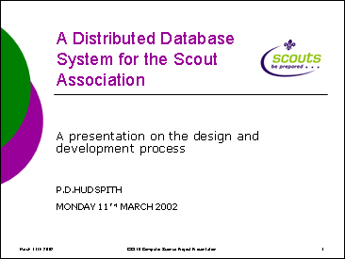 | 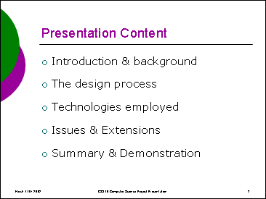
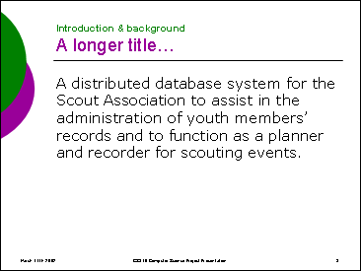 | 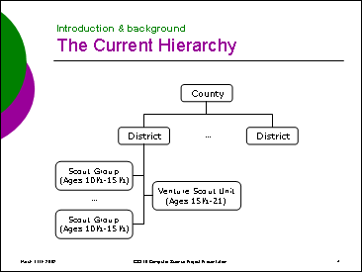
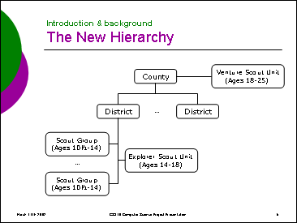 | 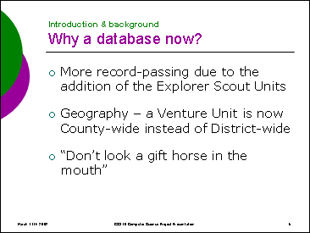
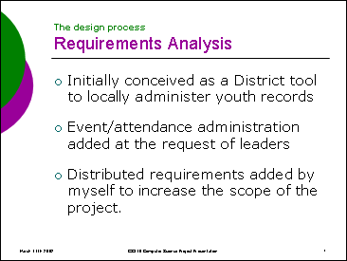 | 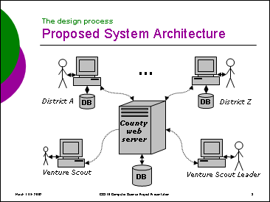
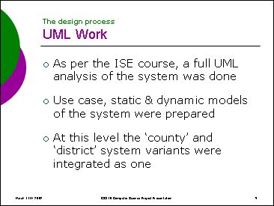 | 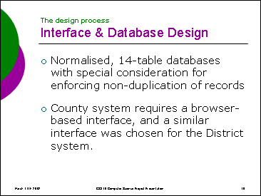
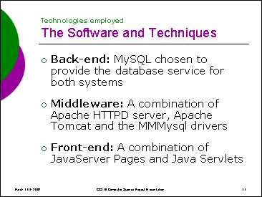 | 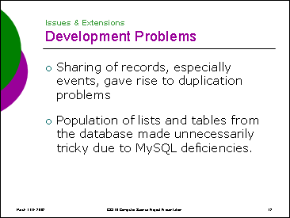
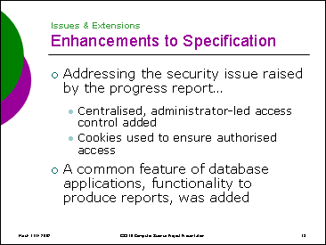 | 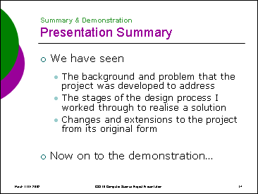

Index

Abstract 5
Access Control
As an Extension 95
Enforcement of 75
Implementation 73
Acknowledgements 100
Active Server Pages 43
Apache
Decision to Use 49
Use with Jakarta-Tomcat 49
ASP See Active Server Pages
Author’s Assessment 7
Awards
Assigning 76
Background 8
Backup
During Development 15
of Database Tables 93
Calendar
Viewing Use Case 17
Cascading Style Sheets
Use in Interface 66
CGI Scripts See Perl Scripts
Class
Entity Class Details 21
Code Commenting 71
Collaboration 32
AddEvent Use Case Collaboration 27
Consolidated Collaboration Diagram 34
Conclusions 94
CSS See Cascading Style Sheets
Data Maintenance 83
Database
ACID Test 39
Choice of technology 38
Entity-Relation Model 52
Interaction with interface,middleware 37
Relation Table 57
Diary 115
Dynamic Model 25
What is a ‘Dynamic Model’ 25
Entity-Relationship Model 52
Consolidated Model 54
County System Model 56
District System Model 55
Why produce? 52
ER Model See Entity-Relationship Model
Event
AddEvent Use Case Dynamic Model 26
Adding an 78
Management Features 77
Recording Attendance at 78
Event Sharing See Networking
Explorer Scout
Unit 10
Extension 6
Functionality
Specified 13
IIS See Internet Information Server
Implementation 71
Information Sharing See Networking
Integrity
Problems & Solutions 57
Interface 42
Choice of Technology 42
Design Methodology 65
Interaction with middleware,database 37
Internet Influences 64
Research & Design 63
Scouting Influence 63
Visual Design 68
Internet Information Server 49
Introduction 6
Jaguar 64
Jakarta-Tomcat
Decision to Use 49
vs. Resin and Jetty 48
Java
Applets as an Interface 45
Code Commenting 71
Javadoc 71
Style Guidelines 73
JavaServer Pages
As an Interface 47
Code Commenting 73
Decision to Use 47
vs. Servlets 84
Jetty 48
JSP See JavaServer Pages
Login 16
Microsoft
Interface Guidelines 65
Middleware 48
Interaction with interface,database 37
MM.Mysql driver package 48
MySQL
Decision to use 42
speed 39
vs. PostGreSQL 38
Networking 81
Sharing Events 82
Synchronising Information 81
Object Structuring 23
Linking Subsystems 25
Objectives
Exceeding 95
Specification Objectives 13
Were they Met? 94
Perl Scripts 45
Personal Web Server 49
PHP 46
PostGreSQL
ACID compliance 39
speed 39
vs. MySQL 38
Preface 6
Presentation 119
Programme Review Implementation 9
PWS See Personal Web Server
Relation Table
County System Model 60
Differences between models 61
District System Model 59
Maintenance See Data Maintenance
Reporting 78
As an Extension 95
Example Reports 117
Resin 48
Scouting
History 8
Mission Statement 8
Organisational Structure 9
Personal Involvement 8
ScoutTrack
Chosen as Name 71
Servlet
vs JavaServer Pages 84
Site Maps 86
County Site 88
District Site 87
Specification
Original 103
Revised 13
SQL
Level of Support by databases 38
Static Model 20
Conceptual Model 21
System Context 20
What is a ‘Static Model 20
synchronisation See Networking
Testing 90
Checking Information Consistency 91
Post-development 90
Programme 90
User Testing 92
With an empty Database 90
Timetable
Policy Review 10
Project Specification 14
Train Line 64
UML See Use Case Model, Static Model
use case analysis See Use Case Model
Use Case Model 16
Complete Analysis 106
Consolidated Model 18
User Acceptance Testing See Testing
User Account
Addition of 74
The Need for 95
Venture Scout
Unit 10
VS Training Database 12
X-Type 64
Youth Record
Adding of 76
AmendYouth Dynamic Model 30
Assigning Awards to 76
Management Features 75

* The Administrator actor cannot view an events calendar
 PL/SQL is a procedural language extension to SQL developed by Oracle Inc. (Oracle Underground, 2002)
# Districts have a unique in-built identity number in their SynchTables and TransferYouth servlets. The Districts’ names are stored in the districts table within the County database, matched to their ID numbers.
 A reference table is defined here as being a one- or two-column table containing elements to be referenced by other tables. Examples include proficiency badges, types of events and names of Scout Groups.

